**AWS EMR**

AWS EMR – Amazon Web Services **Elastic MapReduce (EMR)**

Amazon EMR is a tool for big data processing and analysis. It offers the expandable low-configuration service as an easier way to running in-house cluster computing.

* Cluster & Node - The central component of Amazon EMR is the cluster. A cluster is a collection of Amazon EC2. Here each instance in the cluster is called a node and each node has a role within the cluster, referred to as the node type. There are 3 types of nodes:

1. Master Node
2. Core Node
3. Task Node

* Apache Hadoop - It is an open source distributed processing framework that manages data processing and storage for big data applications
* Amazon EMR processes big data across a Hadoop cluster of virtual servers on Amazon EC2 and Amazon S3 (Simple Storage Service).

**BENEFITS OF AMAZON EMR:**

1. Cost Efficient
2. Allows AWS Integration
3. Easy Deployment
4. Scalable and Flexible
5. Reliable
6. Secure
7. Easy to Monitor
8. Easy Management

**PROCESSING BIG DATA WITH AMAZON EMR:**

* Amazon EMR is used in log analysis for data analysis, web indexing, data warehousing, machine learning, financial analysis, scientific simulation, bioinformatics and more.
* It also supports workloads based on Apache Spark, Presto and Apache HBase.

**ARCHITECHURE:**

1. STORAGE – This layer consists of different file systems that are used in your cluster which you will make. Some of the different types of clusters are:

* Hadoop Distributed File System (HDFS)
* EMR File System (EMRFS)
* Local File System

1. CLUSTER RESOURCE MANAGEMENT – The Cluster Resource Management layer is responsible for managing cluster resources and scheduling the jobs for processing data.
2. DATA PROGRAMMING FRAMEWORK – This layer is the engine used to process and analyze data. The main processing frameworks available for Amazon EMR are

* Hadoop MapReduce
* Apache Spark.

1. APPLICATIONS – Amazon EMR supports many applications to provide capabilities such as using higher-level languages to create processing workloads, leveraging machine learning algorithms, making stream processing applications, and building data warehouses. Some of the applications are:

* Hive
* Pig
* Spark Streaming library

**HANDS ON – HIVE WITH EMR**

**Sign Up for AWS**

Create an AWS account for that open https://portal.aws.amazon.com/billing/signup

After signing in you will see an interface like this

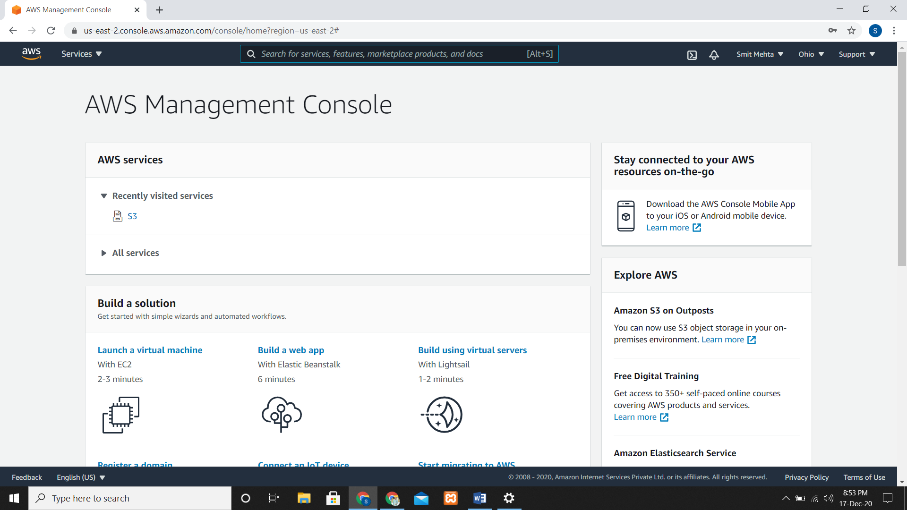

**Create an Amazon S3 Bucket**

S3 Bucket and folder is used to store the output data from Hive query.

* Go to S3 then create bucket, give a name and then hit the create bucket button.

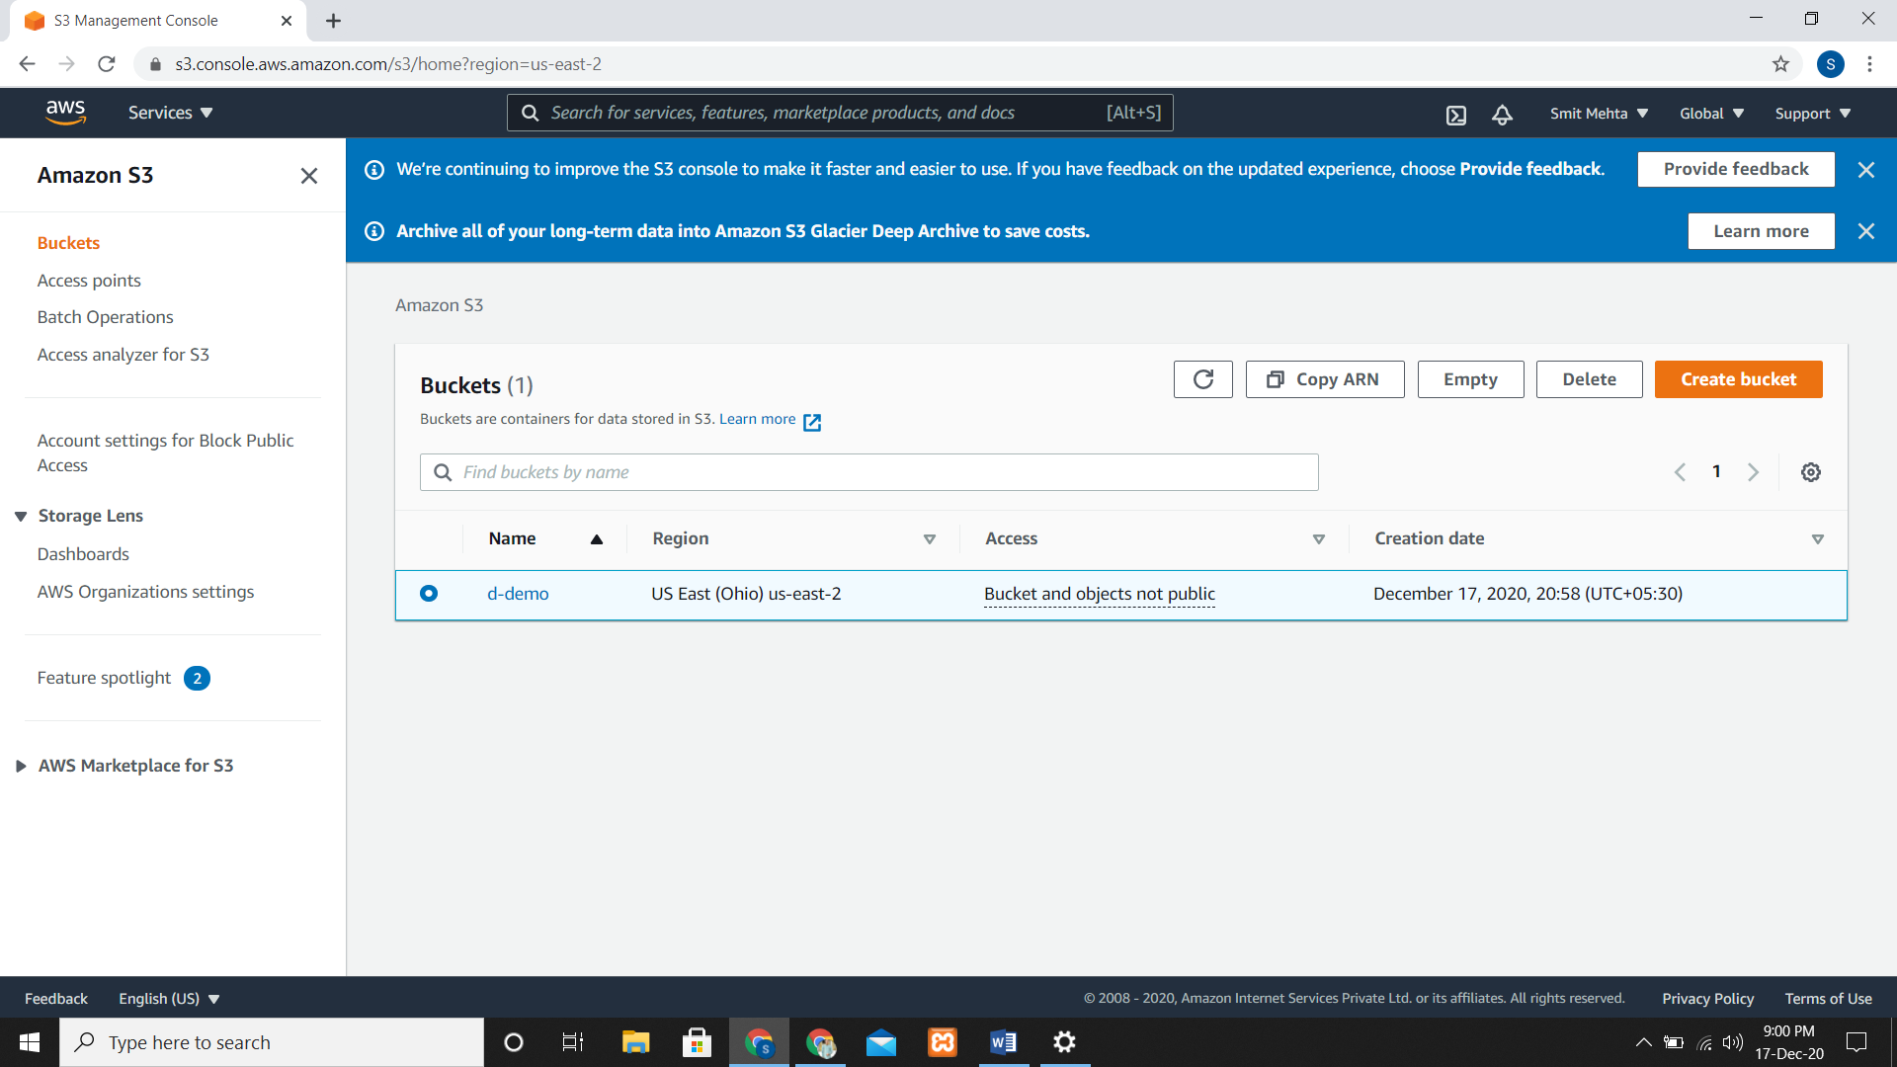

* Now to the bucket and create folder. I have created a **demo** bucket and folder name as **results**.

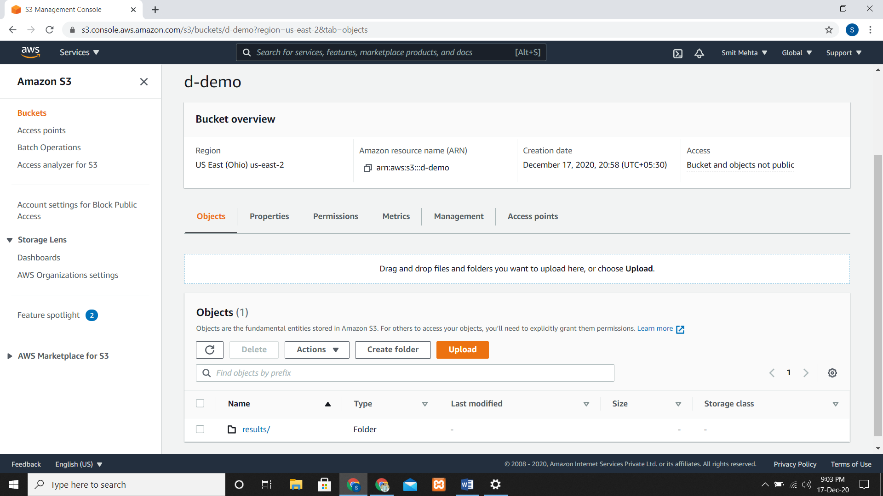

**Creating an Amazon EC2 Key Pair**

Go to EC2, then Key pairs and here create a key pair.

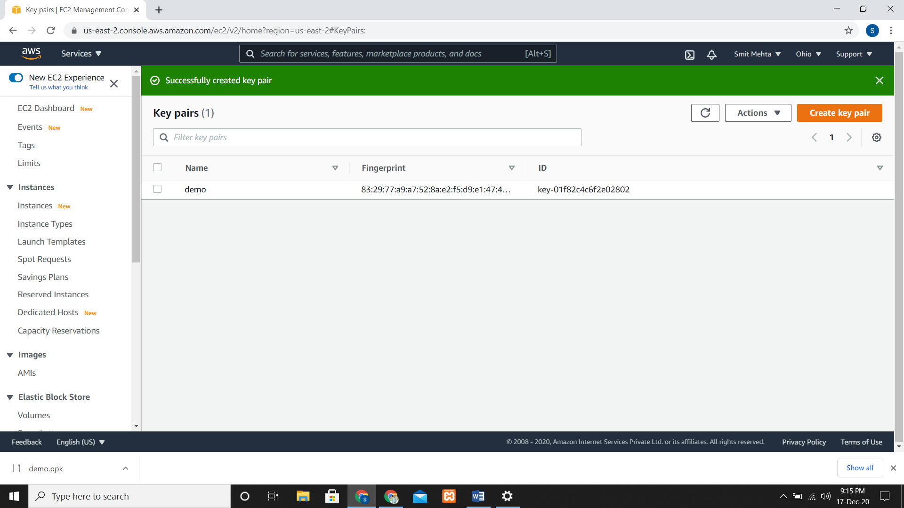

**Launch a Cluster**

Open the Amazon EMR console and create a cluster. Choose create cluster, give a name, choose the application which you want and select your EC2 Key Pair and create it.

It will take some time to create it.

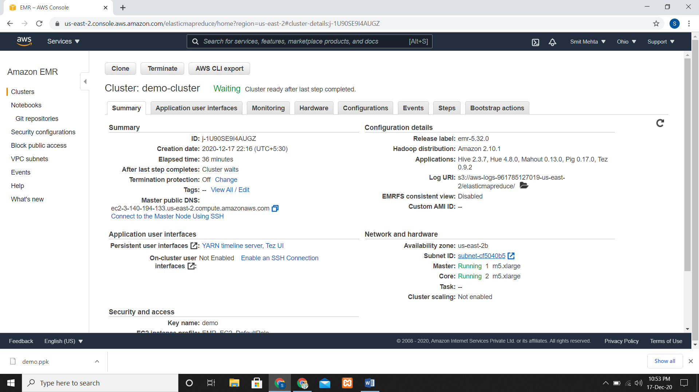

**Allow SSH Connections to the Cluster**

Select your cluster and then go to Security and Access. Now choose Security groups for Master and add Inbound Rules. Add Type – **SSH,** Port – **22** and source – **Custom 0.0.0.0/0**

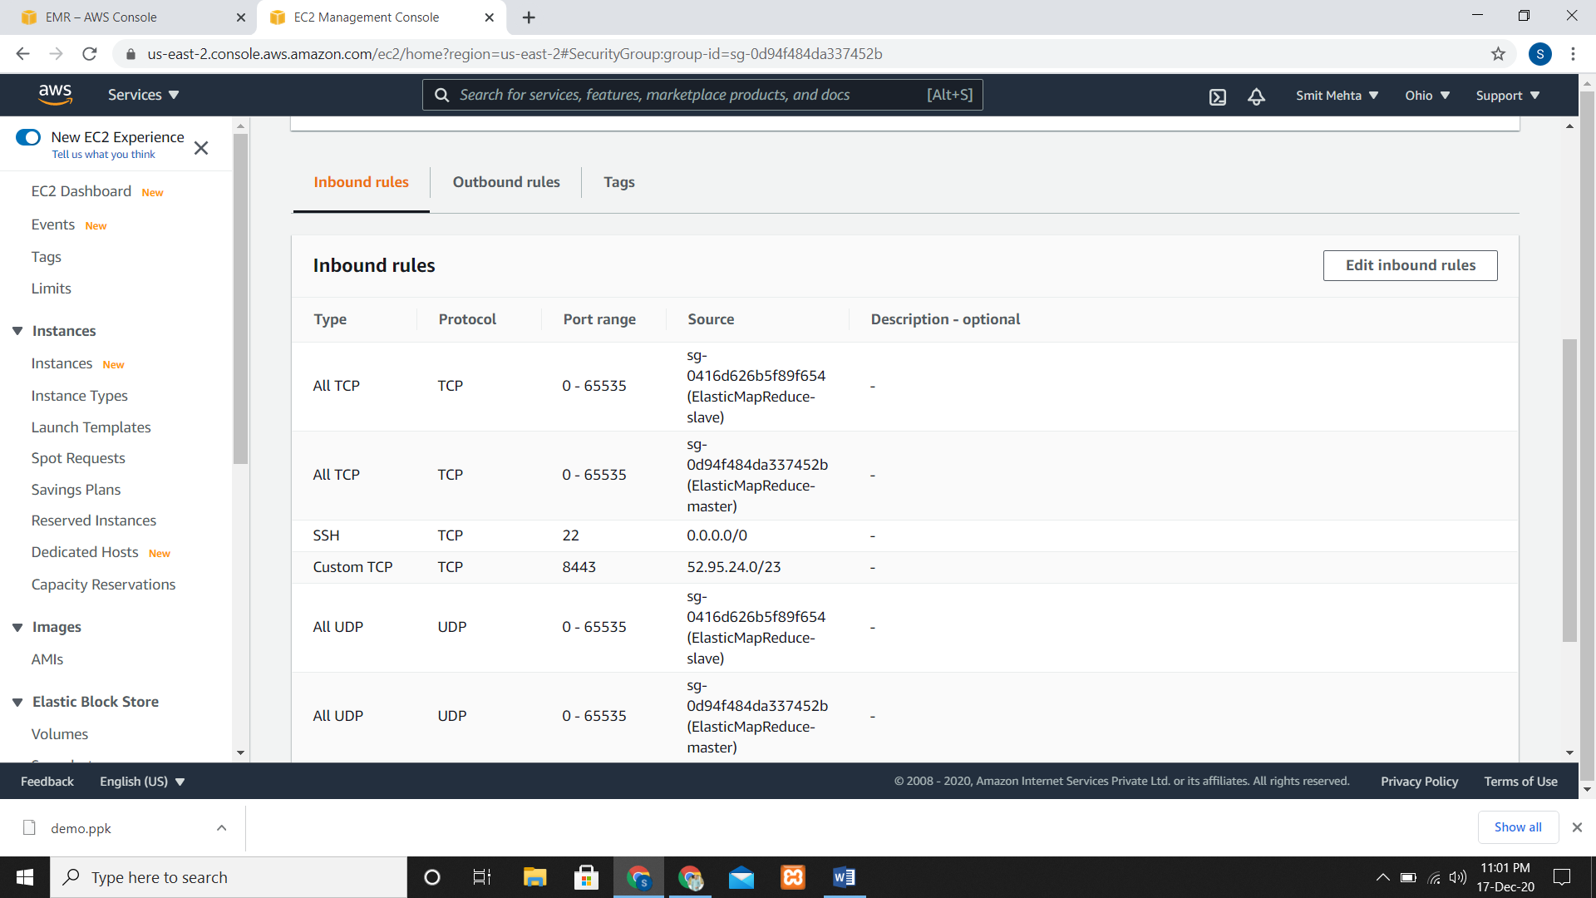

**Processing Data By Running The Hive Script as a Step**

* A sample data and script that we have used is already available in an Amazon S3 location.
* Select a cluster but it must be in waiting state.
* Now go to **Add Steps**

1. Step type – **Hive Program.**
2. Name – **Give any name**

Now while adding the location, you have to select your own **region**

1. Script S3 Location –

**s3:// us-east-2.elasticmapreduce.samples/cloudfront/code/Hive_CloudFront.q**

1. Input S3 Location - **s3:// region.elasticmapreduce.samples**
2. Output S3 Location - **Browse to the bucket location where you want the output.**
3. Action on Failure – **Continue.**

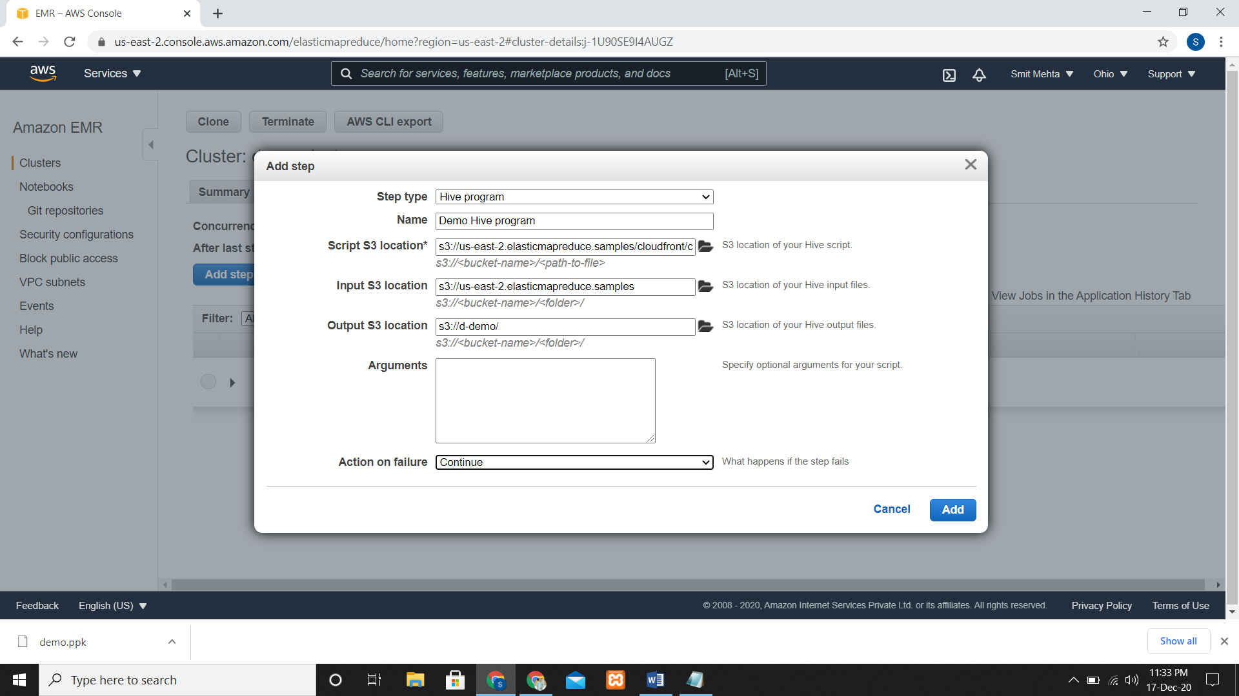

* It will take some time and after status changes from **pending** to **running** to **completed** you can check the output

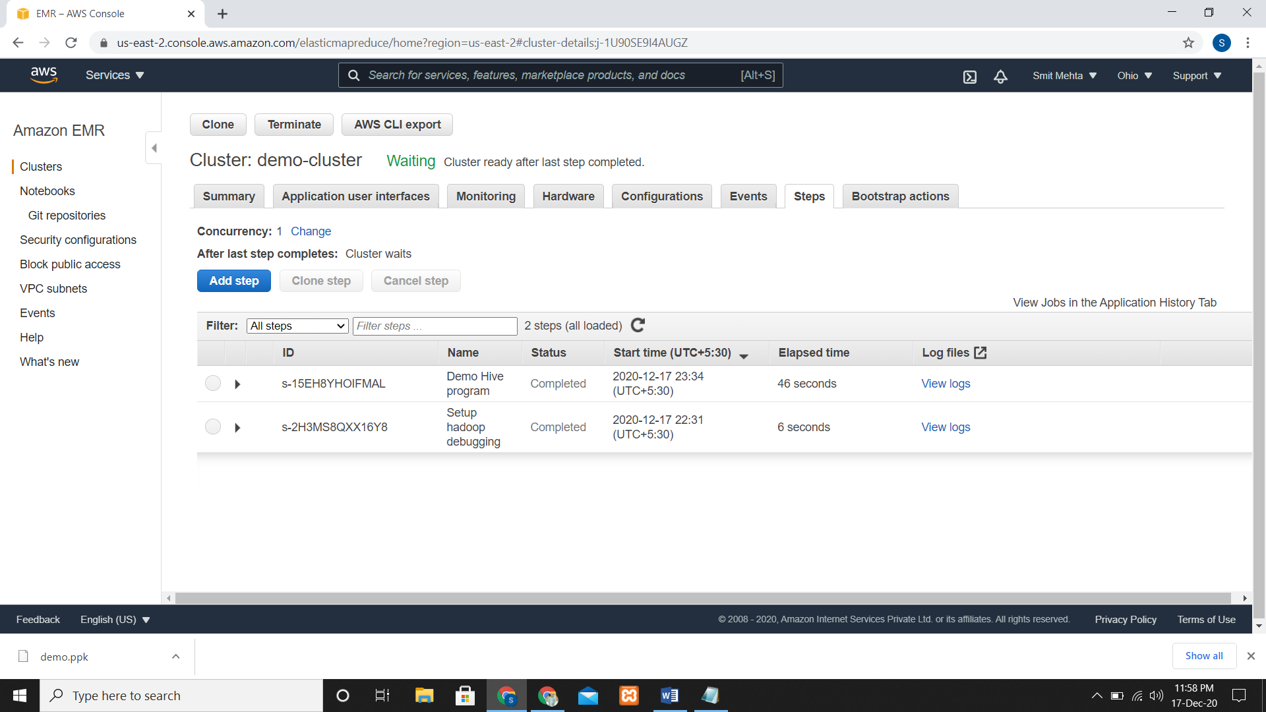

* Now for checking the output go to your bucket name where you wanted your output check in the folders there will be files.

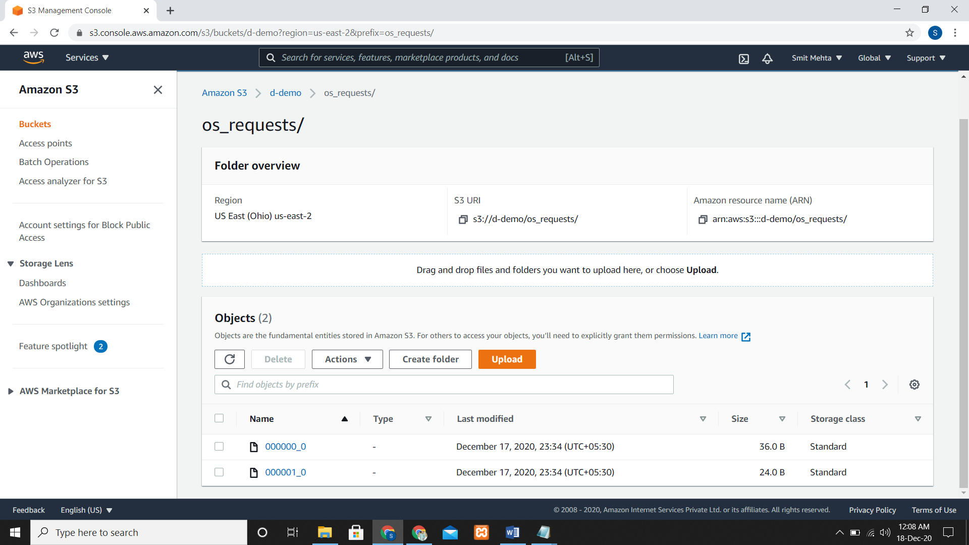

Click on that file, download it and open it you will get the output file

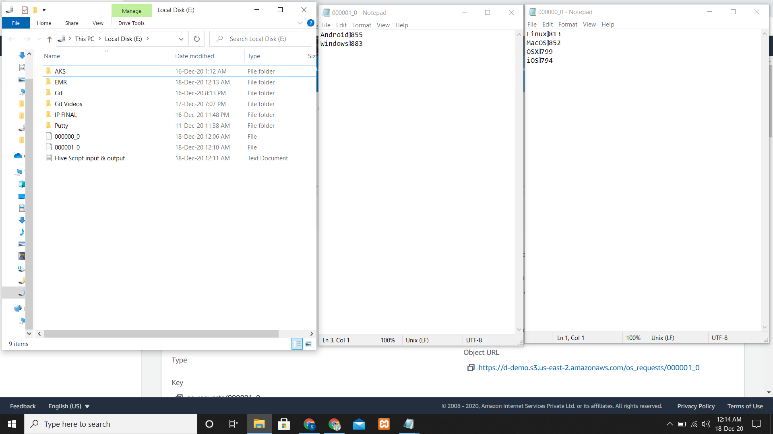

**To Terminate the Cluster**

* Go to your Cluster, Select and open it and click on **Terminate**

**To Delete the Output Bucket**

* Go to S3, select your Bucket and click on Delete. Now re-enter your bucket name and delete it.

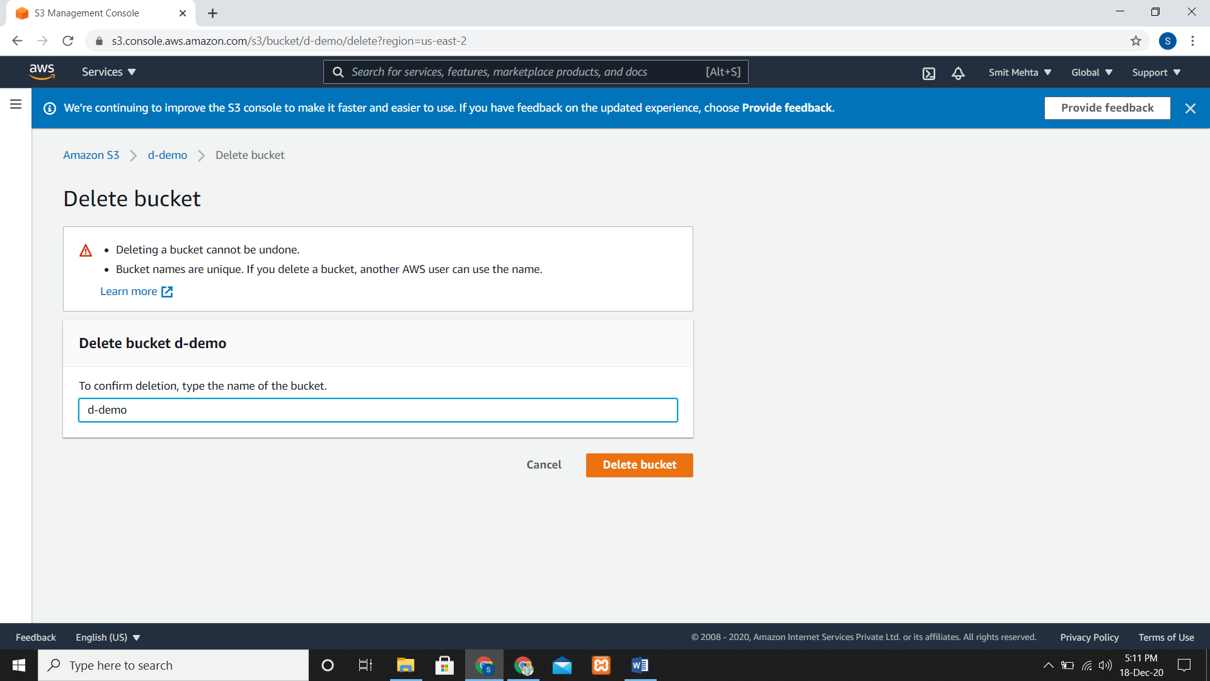

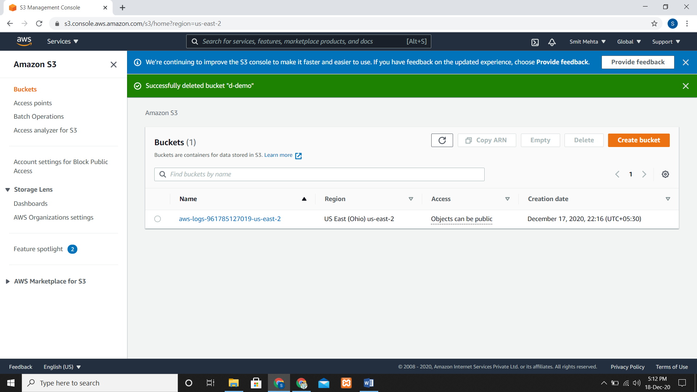

**AMAZON EMR NOTEBOOK**

* For running Apache Spark and to create and open Jupyter we can use Amazon EMR Notebooks.
* For creating Notebook go the notebook and create it.
* Give Notebook name, Create/Choose a cluster according to the requirements.
* Now choose the location for the output of Notebook and choose a key pair and create it.

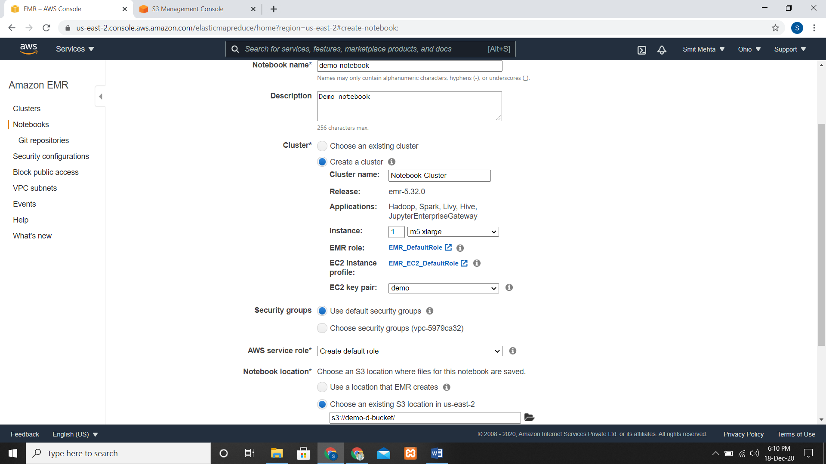

* After some time the status will change to **PENDING/READY,** now you can use Jupyter.

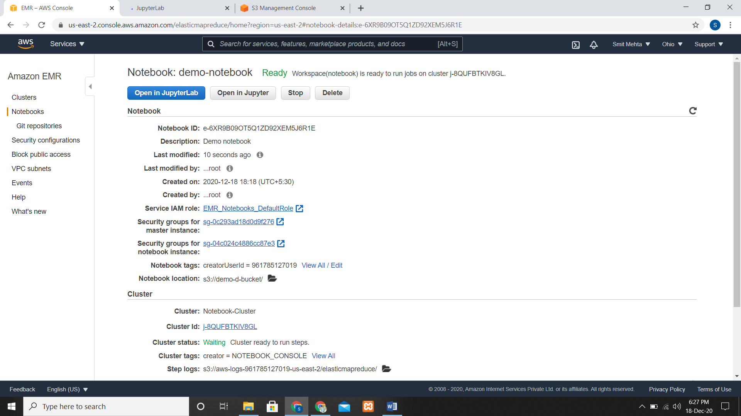

**To open the notebook editor for an EMR notebook**

* Open JupterLab and Select your Kernel and start the code.

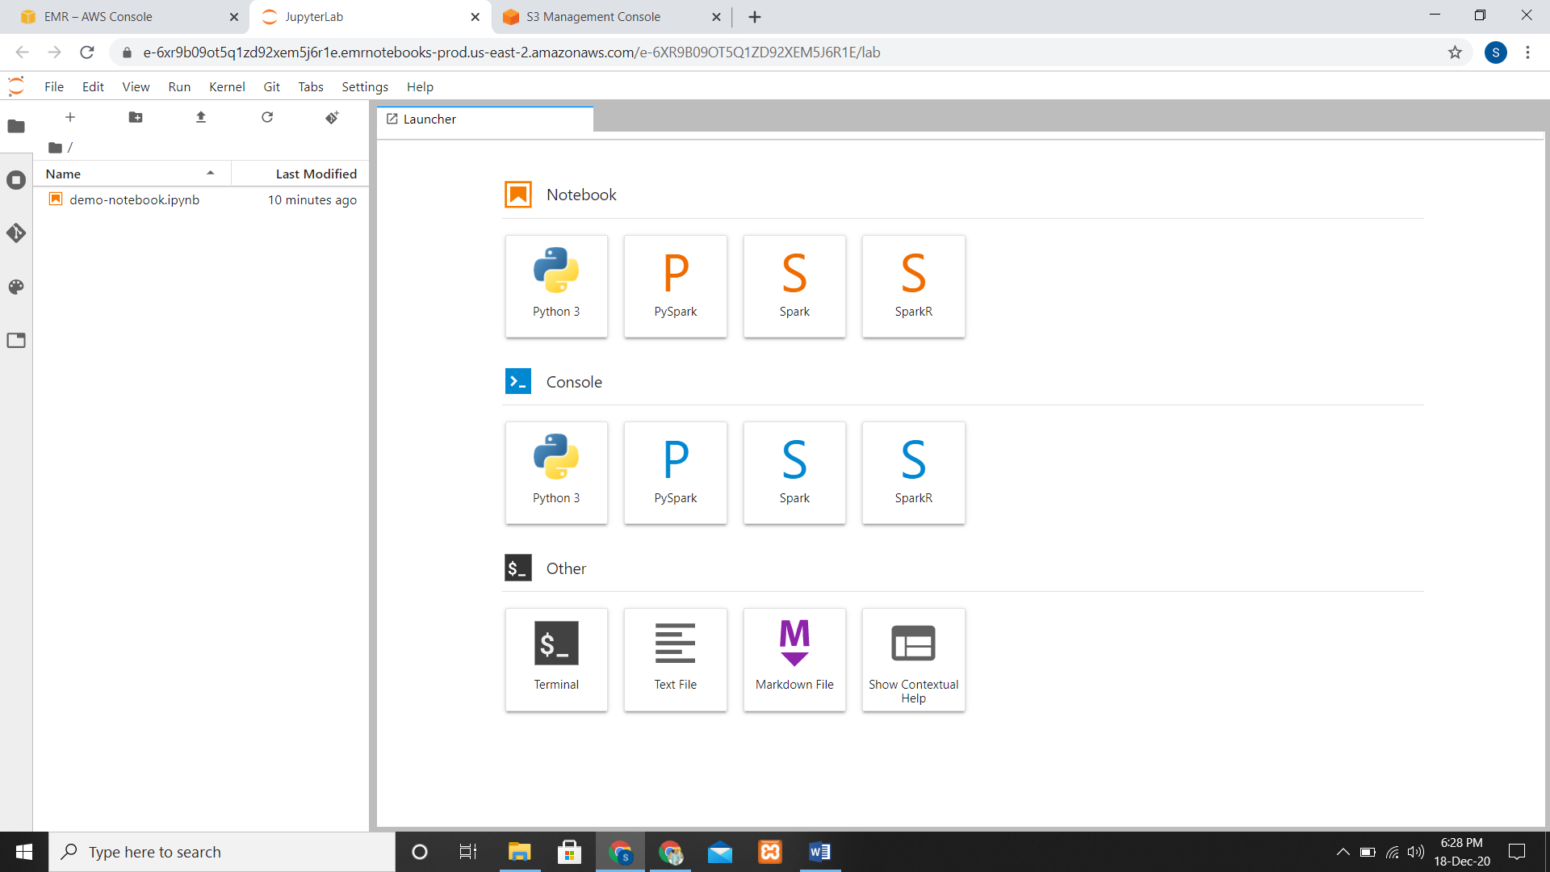

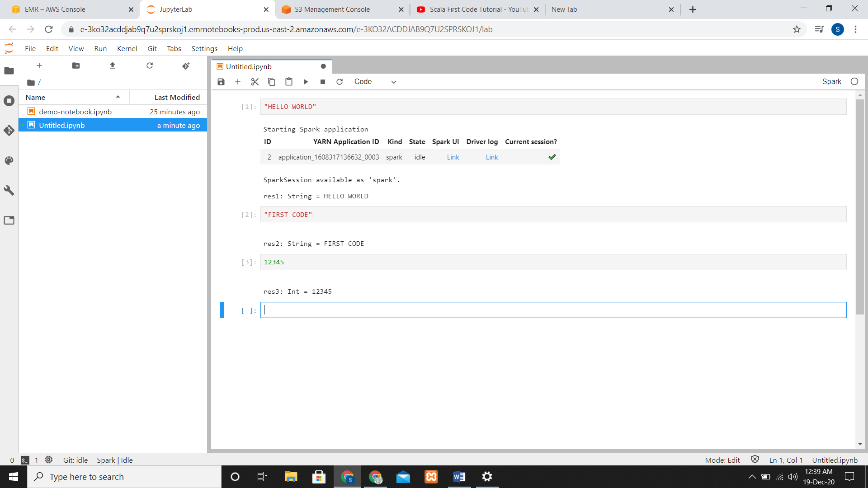

**Saving the Contents of a Notebook**

* After writing the code just save it by pressing CTRL + S or doing it manually.

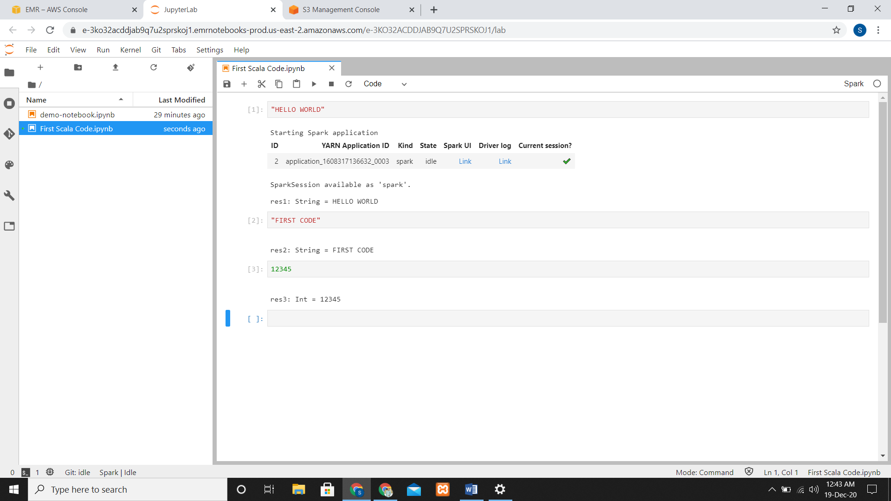

**Changing Clusters**

* Stop your current notebook, go to list and click on change cluster.
* Now select the cluster you want.

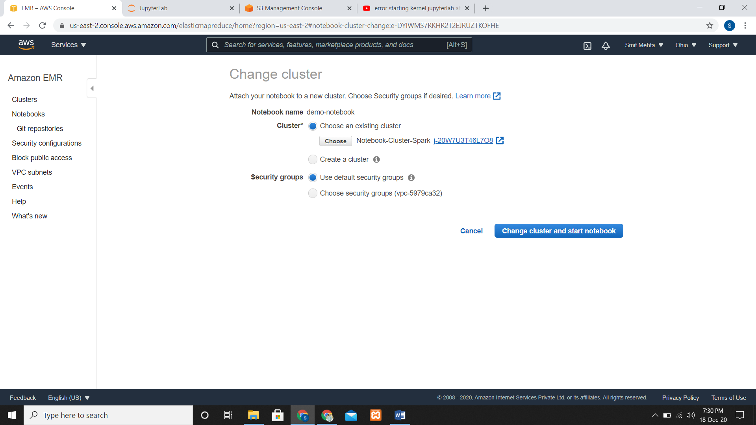

**Deleting Notebooks**

* Choose the Notebook Stop it and click on delete and confirm it.

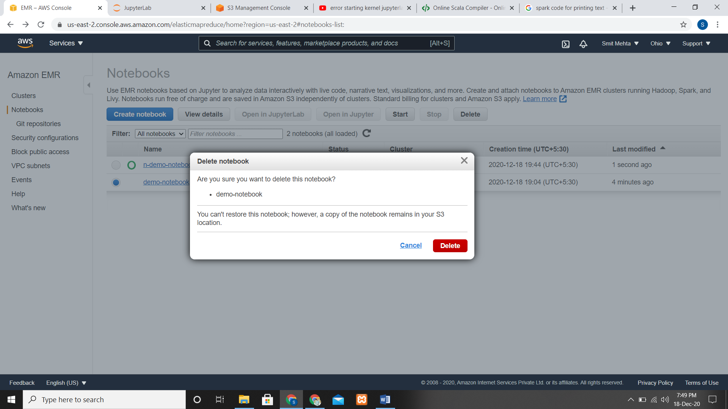

**Associating Git-based Repositories with EMR Notebooks**

* Checking the Inbound and outbound rules of Security Group for EMR Notebooks
* By adding Git-based Repositories with your Amazon EMR notebooks you can save your notebooks in VCS.

**To ADD a Git-based repository as a resource in your Amazon EMR account**

* In the console go to repositories and click add repositories.
* Enter name and for Git repository URL https://git-codecommit.region.amazonaws.com/v1/repos/MyCodeCommitRepoName
* Enter a branch name and choose your Git Credentials.

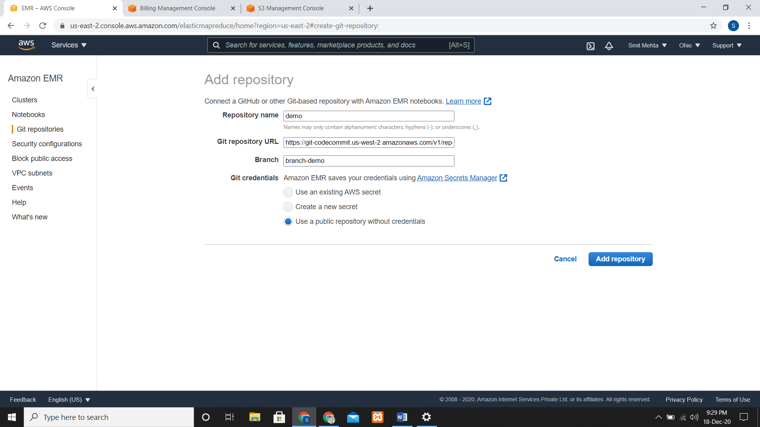

**UPDATE your Git-based Repository**

* Open you git-based repository and click on EDIT and make changes as you want.

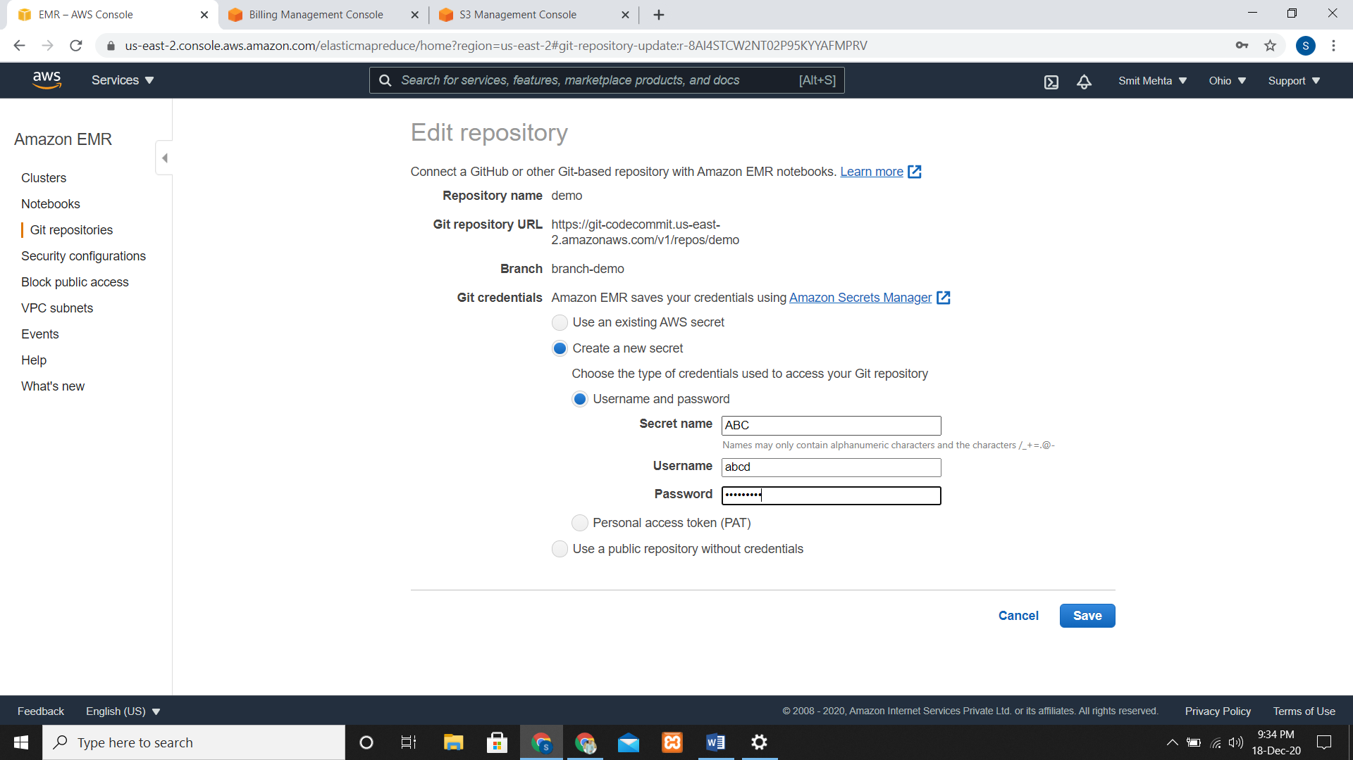

**DELETE a Git-based Repository**

* Open you git repository, choose your repository and click on DELETE.

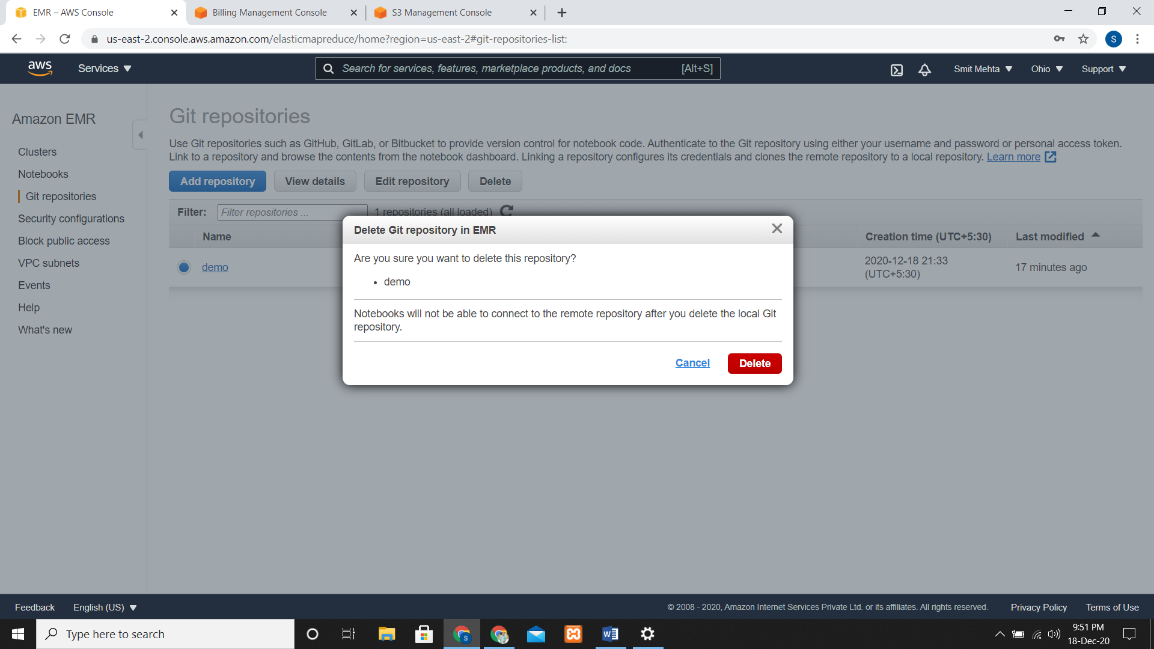

**LINK a Git-based Repository**

* Go the git repository which you want to link, open it and click on the LINK new notebook.

**UNLINK a Git-based Repository**

* Go the git repository which you want to link, open it and click on the LINK new notebook.

**Create a NEW NOTEBOOK with an ASSOCIATED GIT REPOSITORY**

* Same steps as creating a notebook, choose a git repository of your choice.

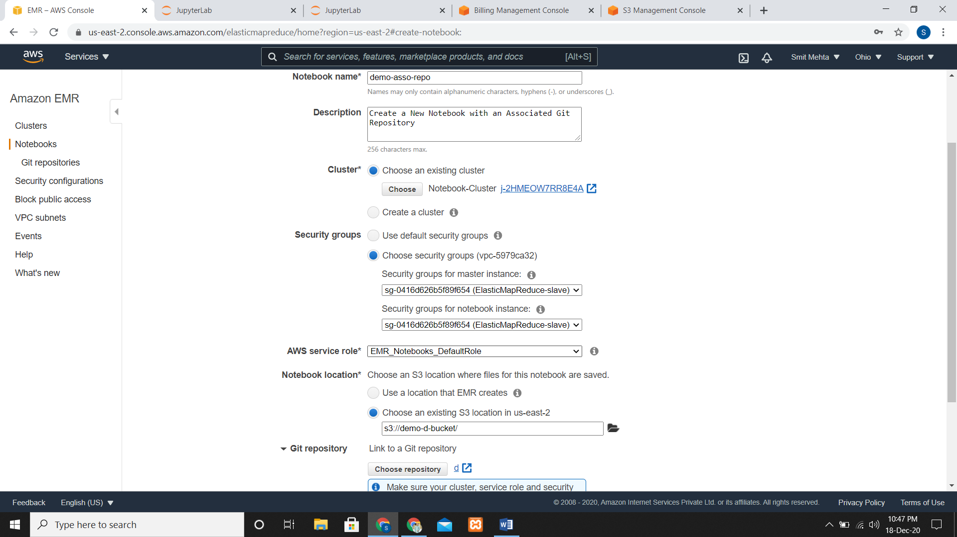

* After creating the notebook go to the Security Groups of Notebook Instance and create your own Security Group and add Outbound rules

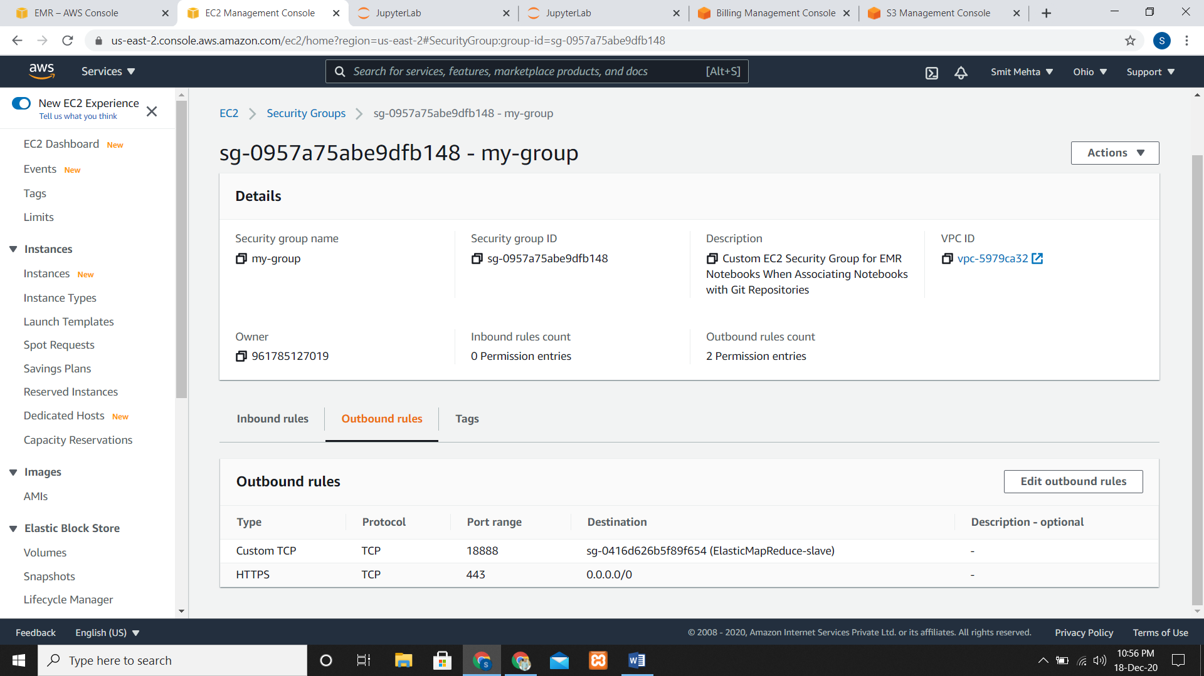

**Specify a Region Using the AWS CLI**

* Here you need to create a user under the IAM role and get the access key and security key

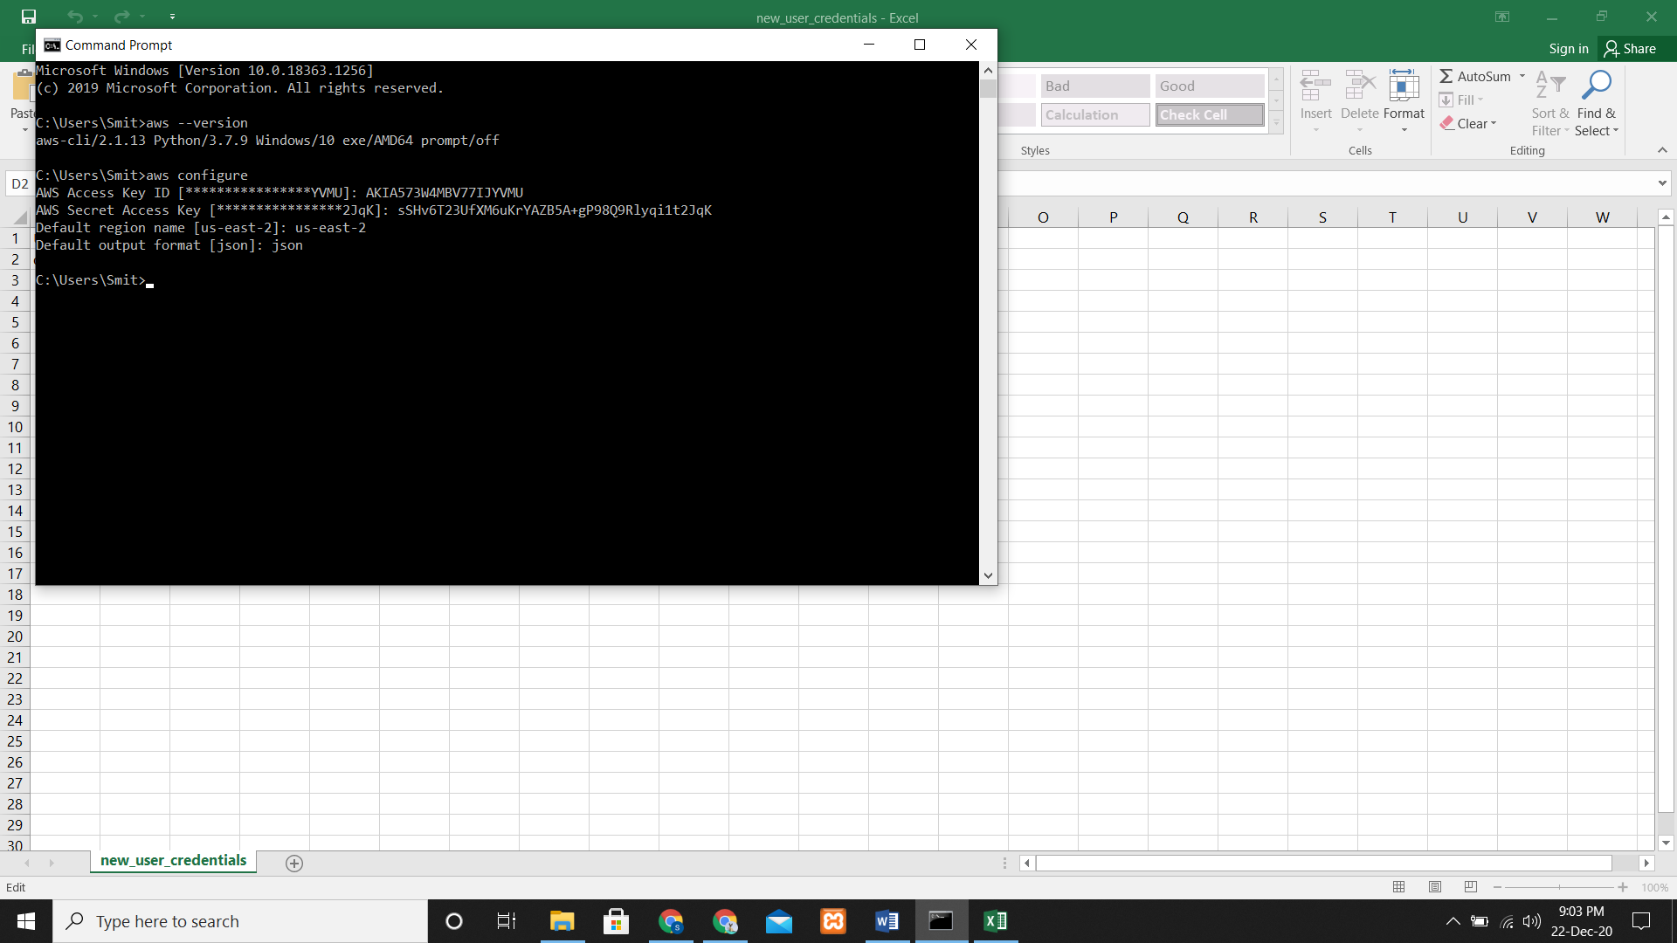

* For setting a particular region

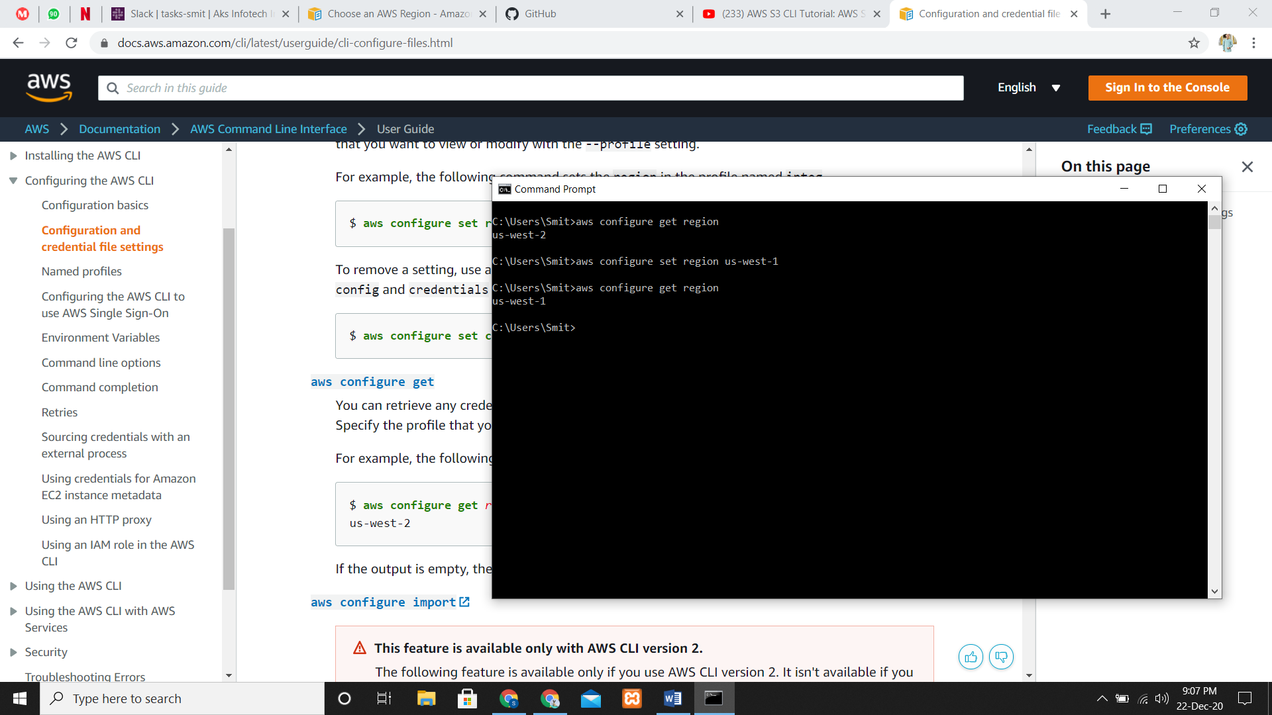

**Creating s3 bucket using AWS CLI**

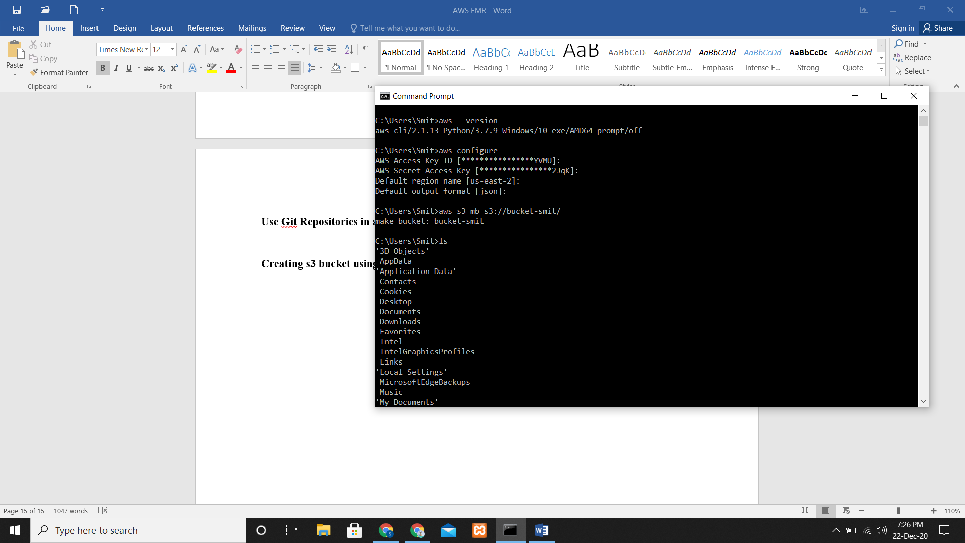

**Adding files in s3**

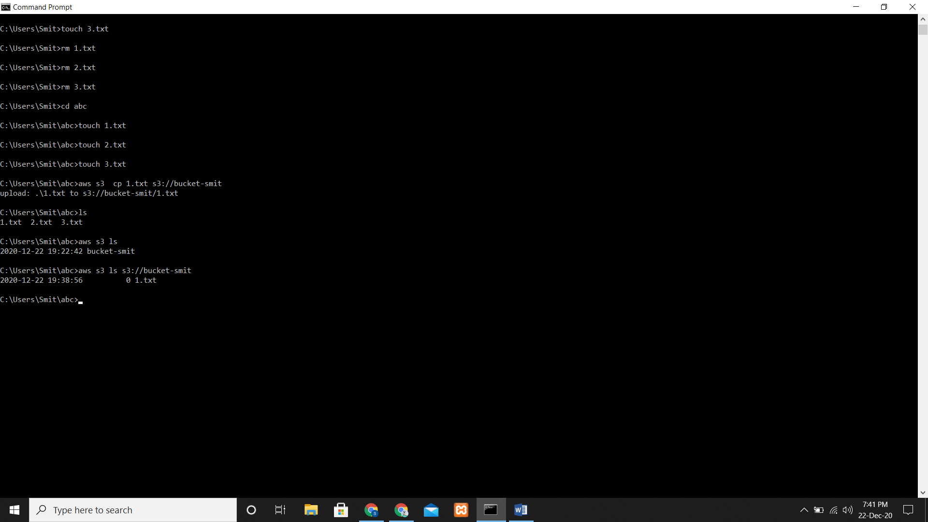

**Connect to the Master Node Using SSH on Windows**

* Create a cluster copy the master public DNS, paste under the host name and add your key pair i.e. .ppk file to Auth in Putty.

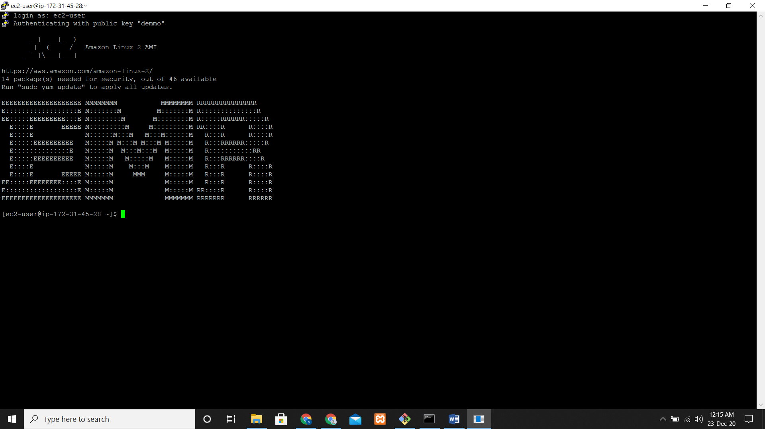

**Connect to the Master Node Using the AWS CLI**

* Add an inbound rule in the Security group for Master as type = SSH and port = 22
* Add the same rule for ElasticMapReduce-slave and give permission as AmazonElasticMapReduceFullAccess to your user.

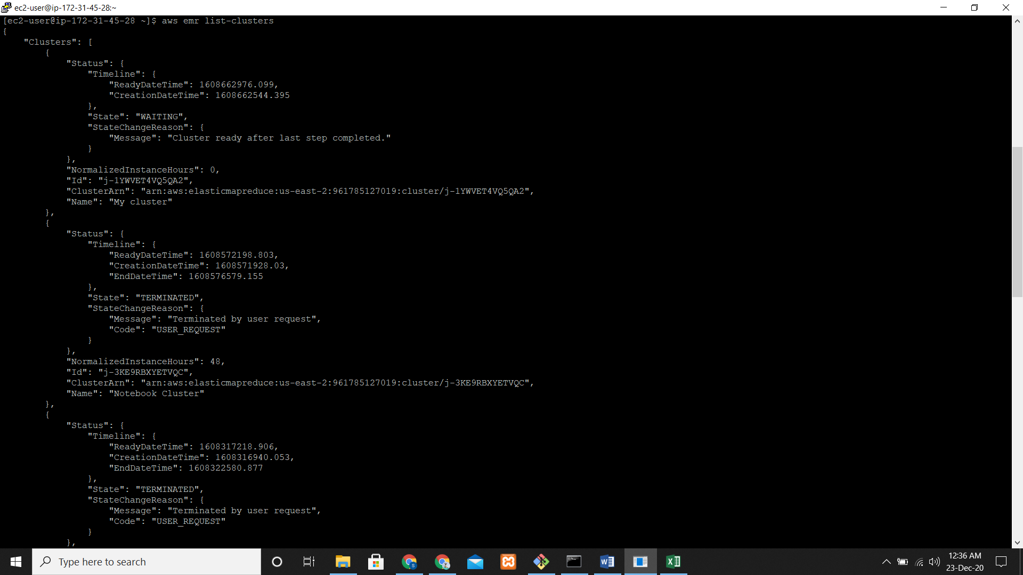

**Create a Profile using AWS CLI**

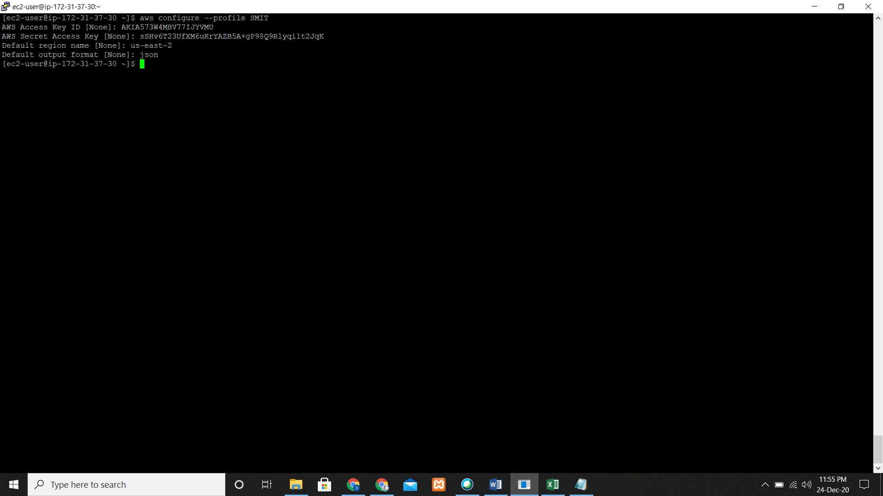

**Creating a cluster with Multiple Master Nodes**

* Go to clusters and click on advanced settings and now click on **Multiple master nodes** and select the other required options

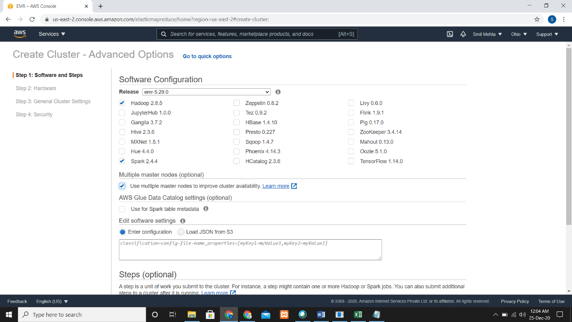

* After your cluster is ready, there will be **3 Master Public DNS**

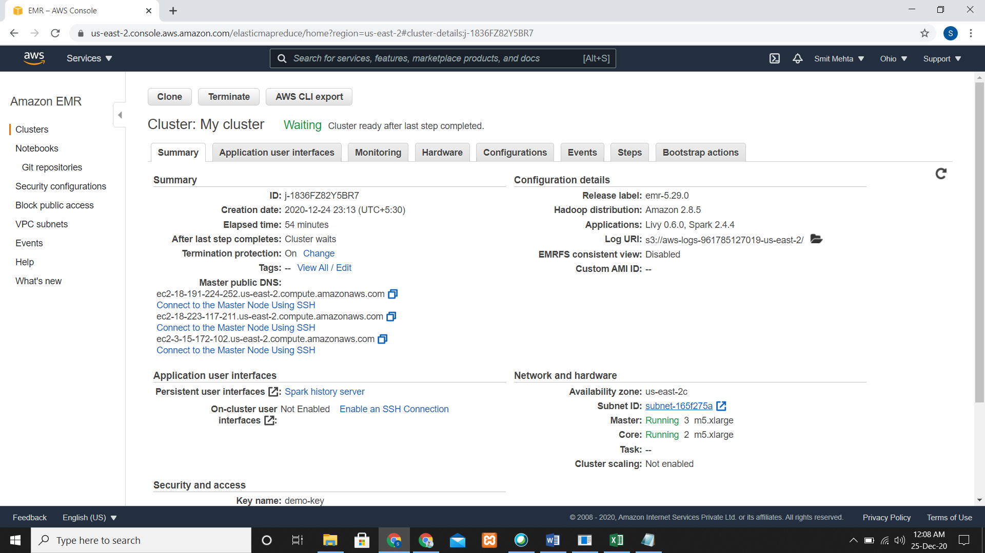

* There are some features that are unsupported when you create a cluster using multiple master node.

1. EMR Notebooks
2. Instance fleets
3. One-click access to persistent Spark history server
4. Persistent application user interfaces

**High Availability HDFS**

* If you need to find out which NameNode is active, you can use SSH to connect to any master node in the cluster and run the following command:

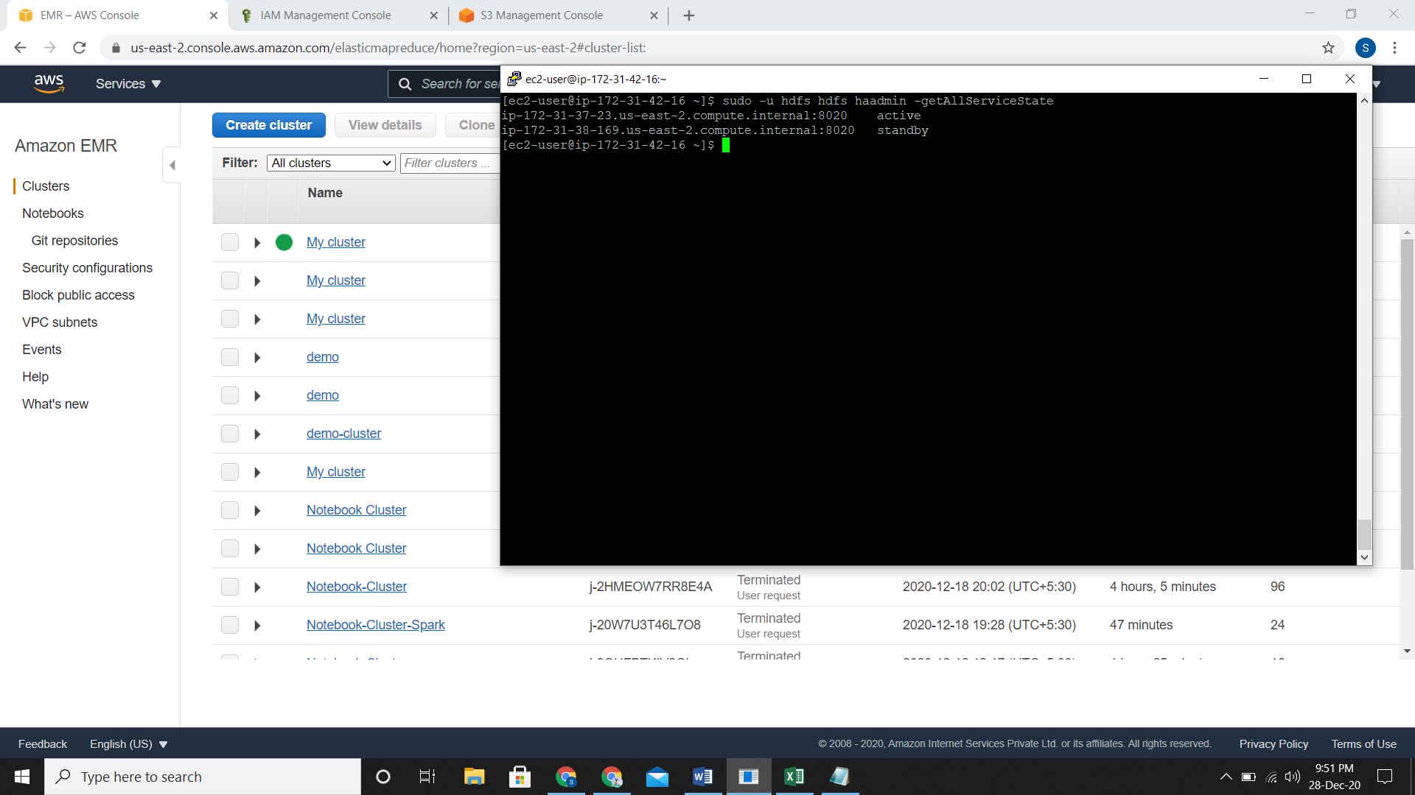

**High Availability YARN ResourceManager**

* Here it tells about the multiple master node that are created.
* Out of the three master nodes you can connect any of them.

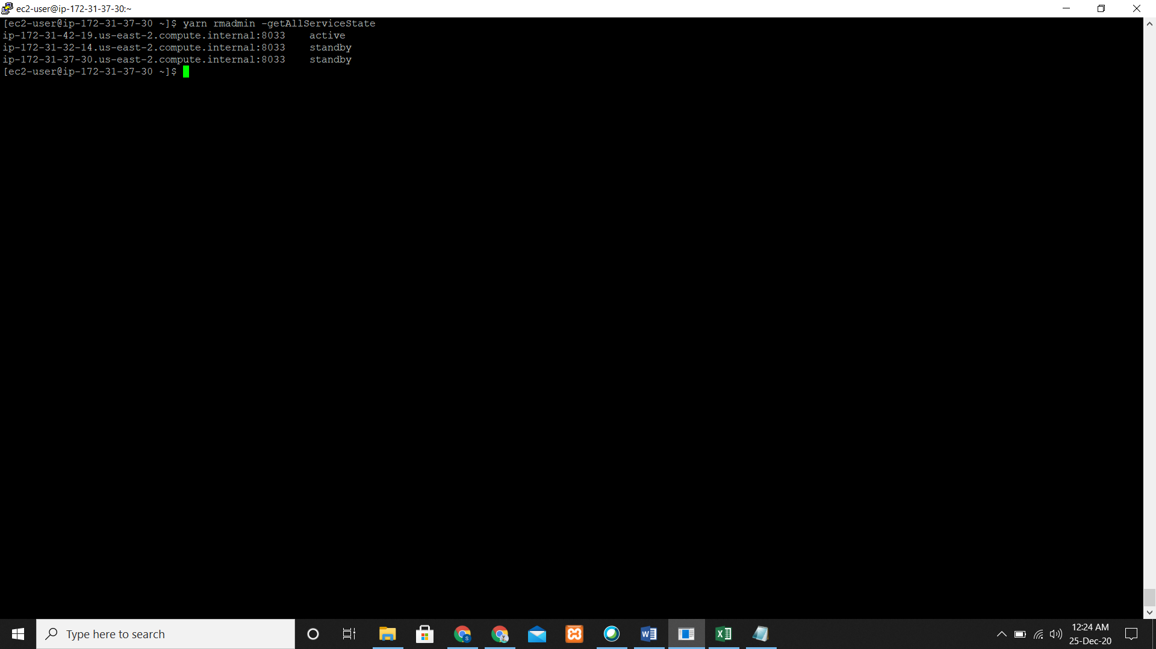

**Creating EMR Cluster with Multiple Master Node on AWS CLI**

* You need to give the administrative policies to your users.
* Firstly, you must enable the instances in this subnet to receive a public IP address by selecting Auto-assign IPv4 in the console by the code: aws ec2 modify-subnet-attribute --subnet-id subnet-subnet_id --map-public-ip-on-launch
* Now simply launch the cluster with the following command

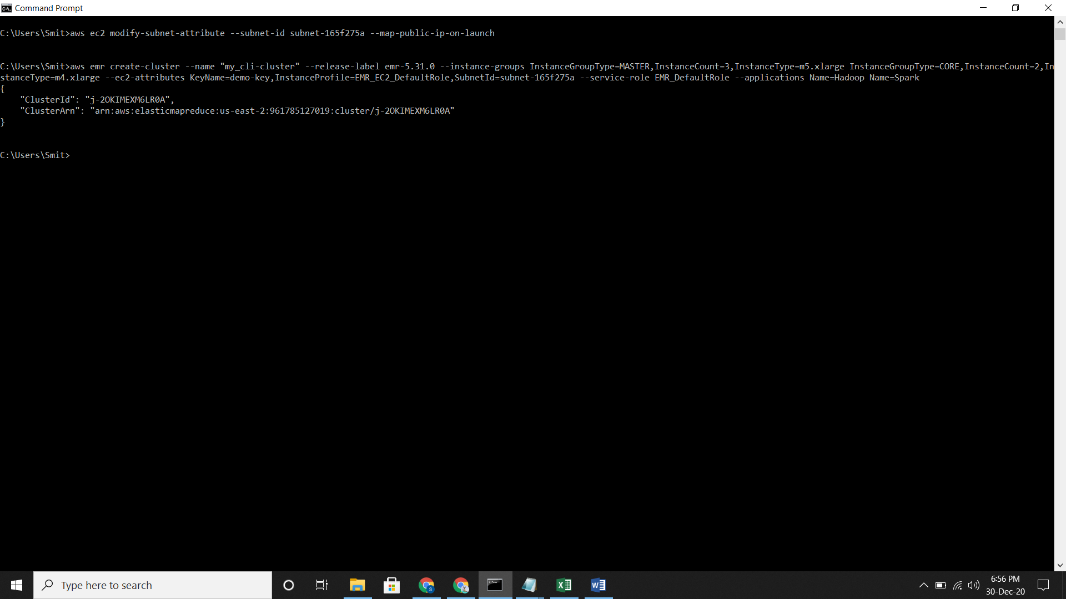

* Clusters on AWS EMR console

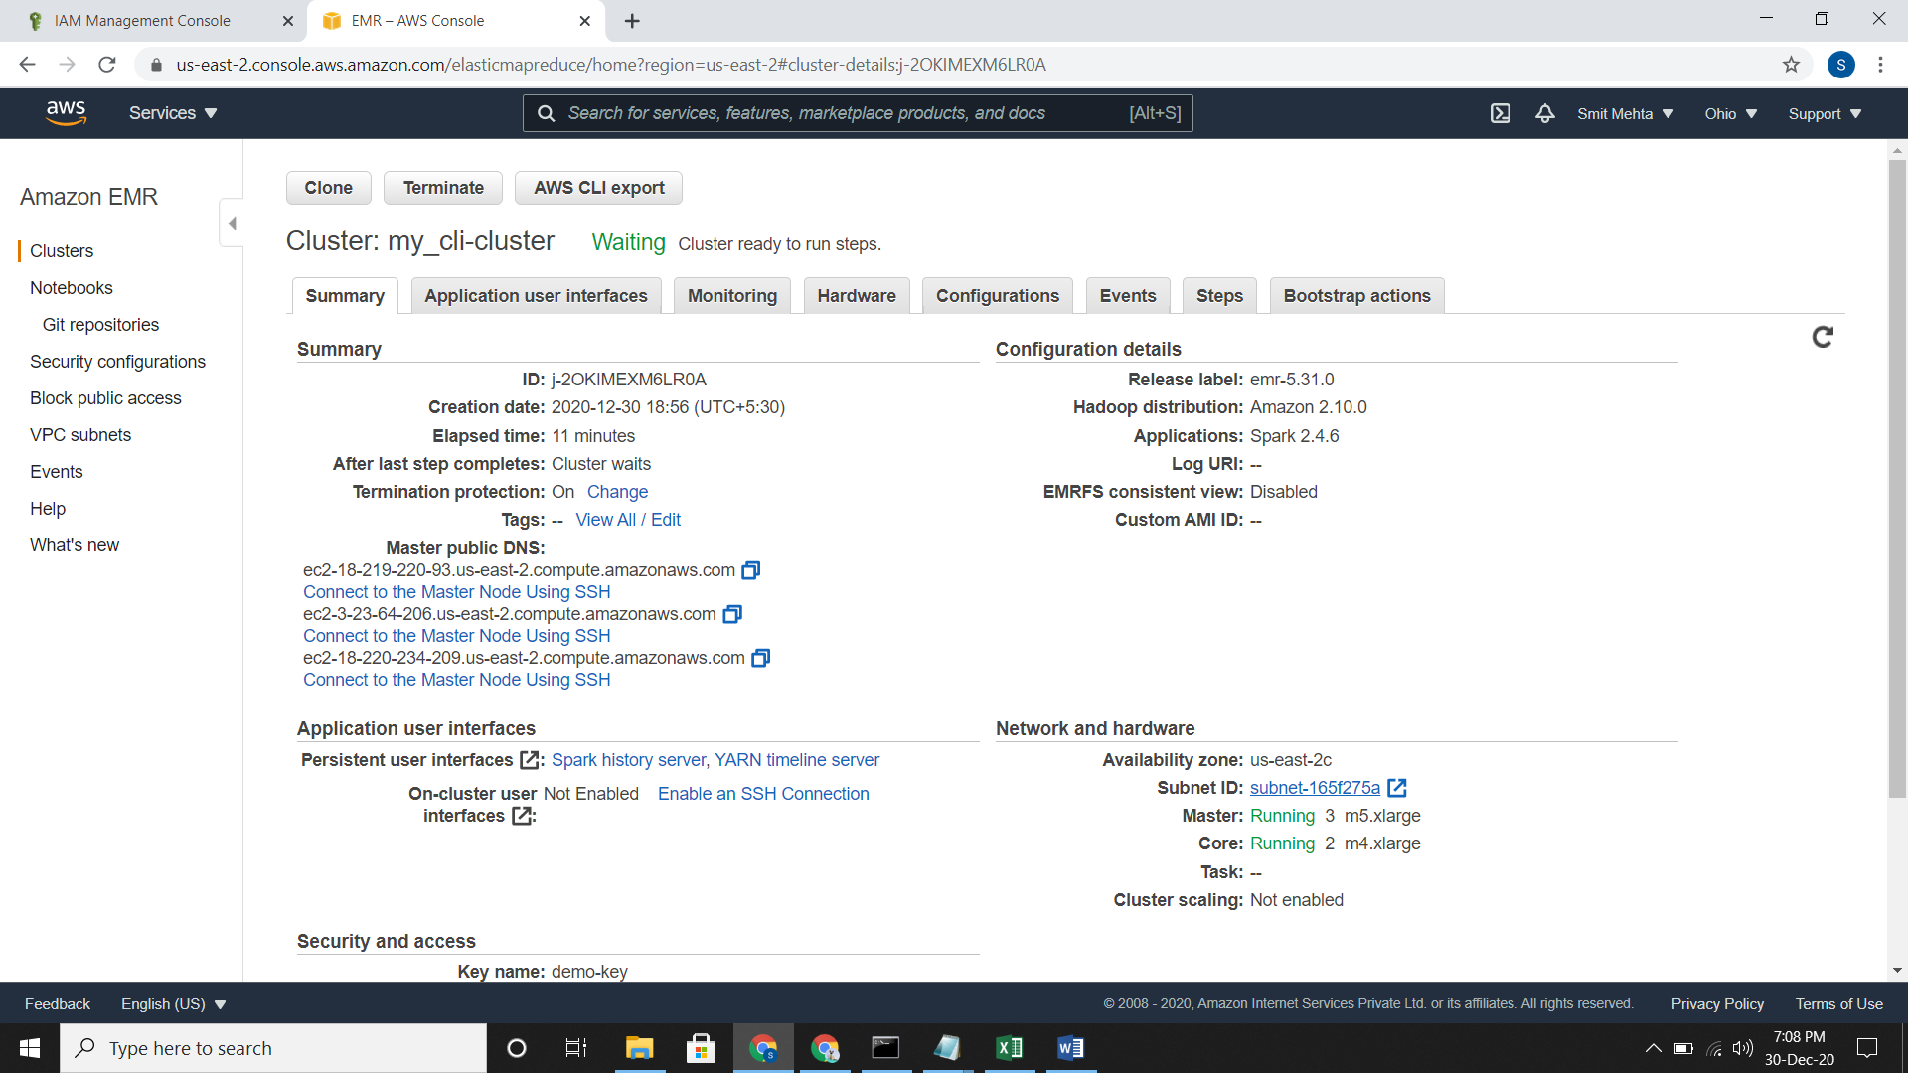

**Terminating a Cluster in AWS CLI**

* You must disable the termination protection before you run the termination command
* Command aws emr modify-cluster-attributes --cluster-id j-2OKIMEXM6LR0A --no-termination-protected

aws emr terminate-clusters --cluster-id j-2OKIMEXM6LR0A

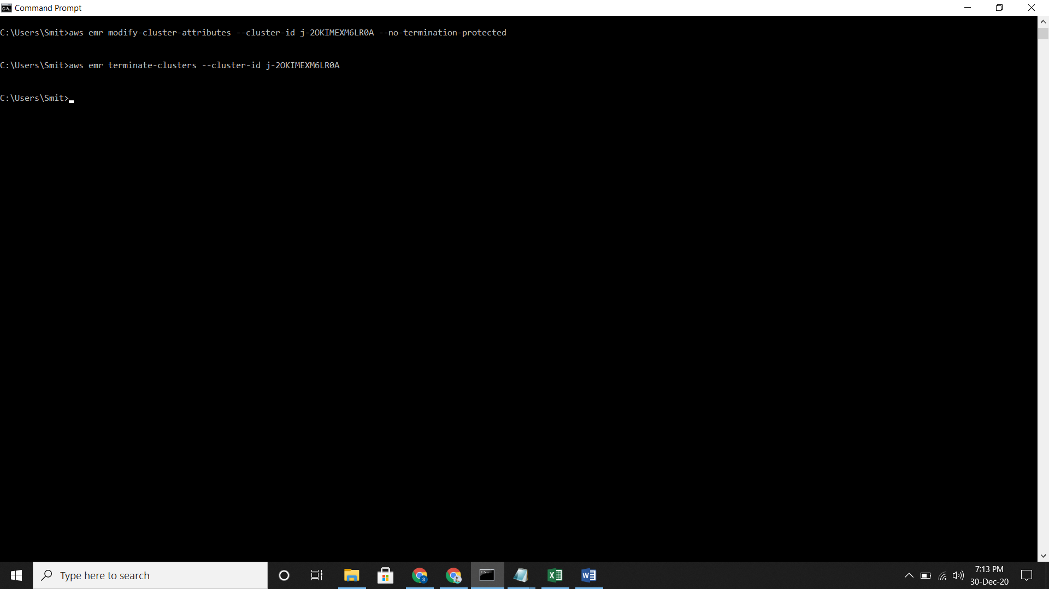

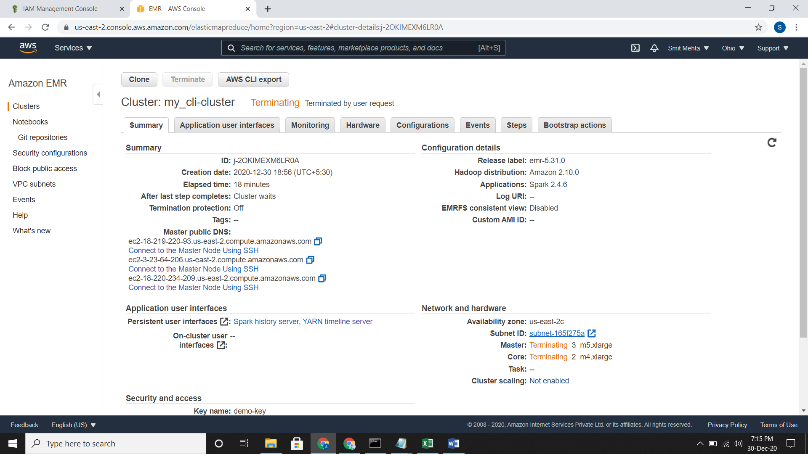

**Attaching the placement group managed policy to the EMR role**

* Go to the user, select the user and add the placement group policy and EMR reduce role policy

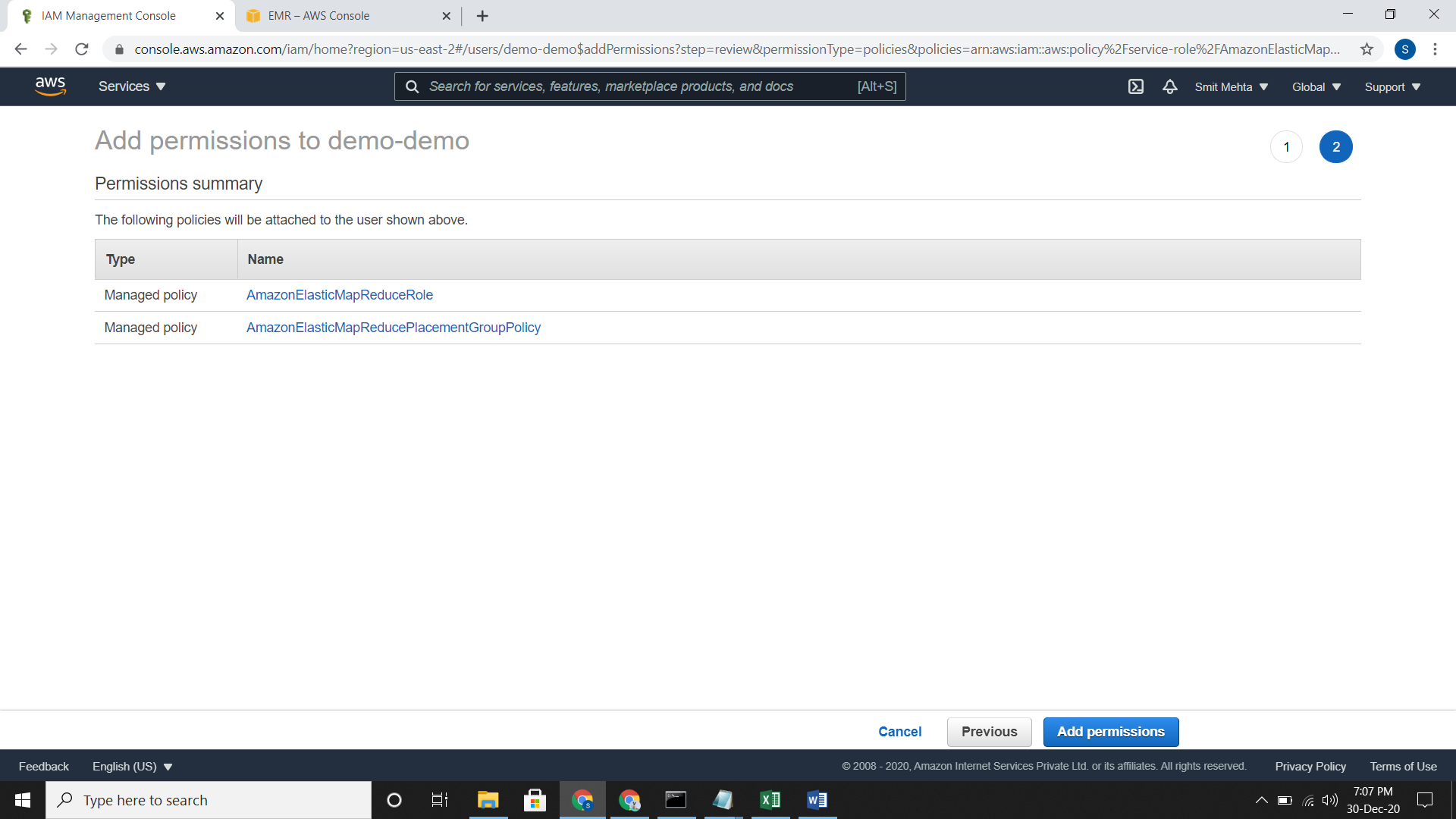

* Attach the given policies to EMR_DefaultRole

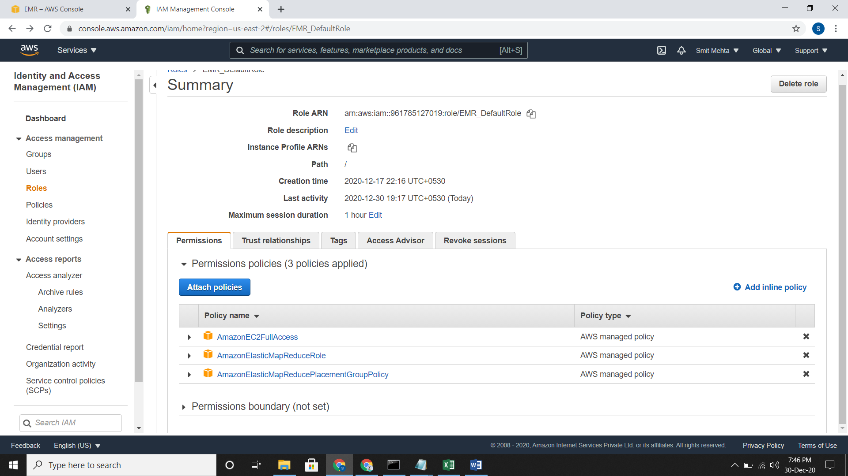

* Now you can launch the cluster using CLI

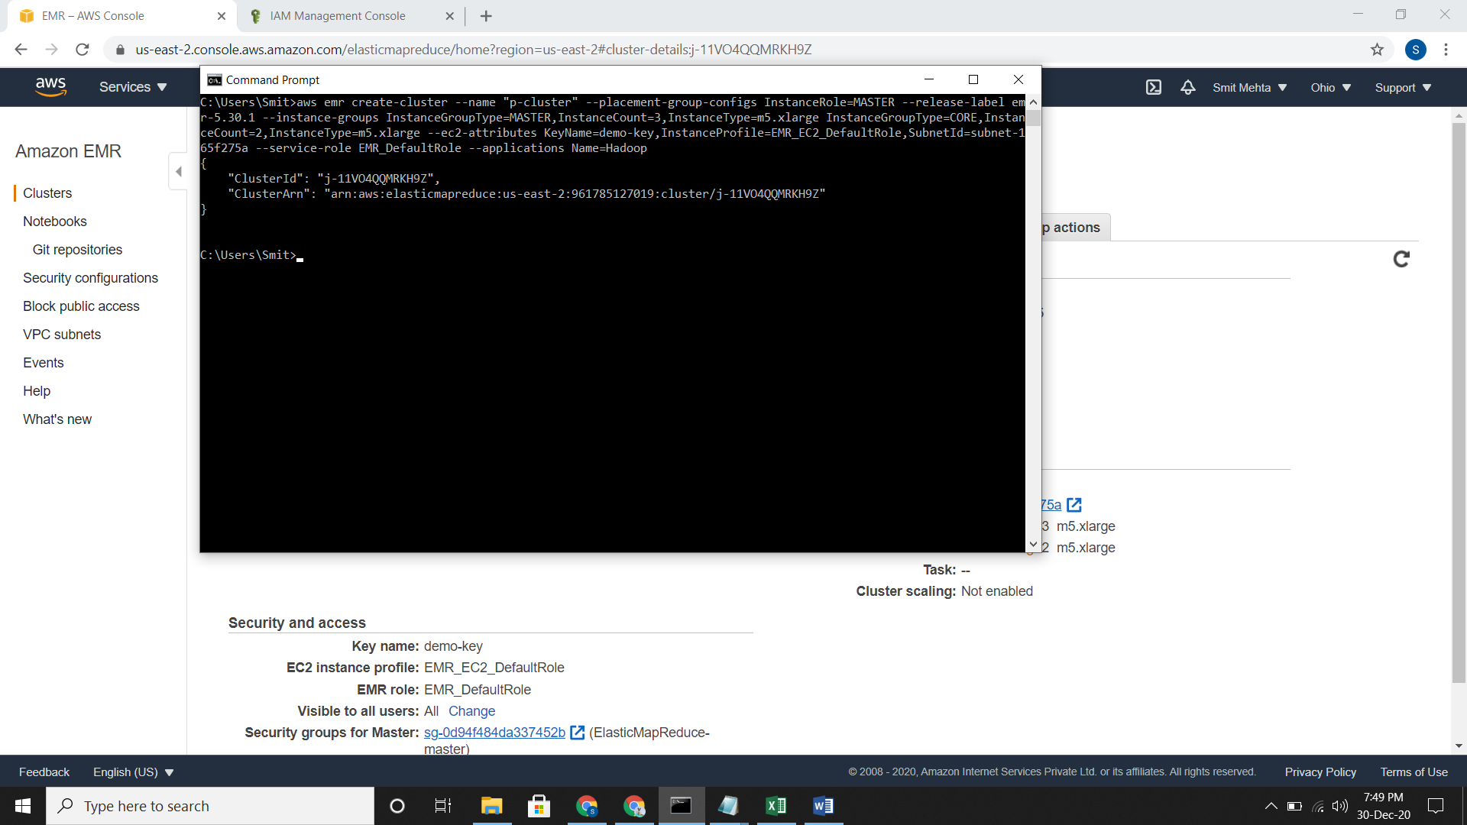

* Clusters on AWS EMR console

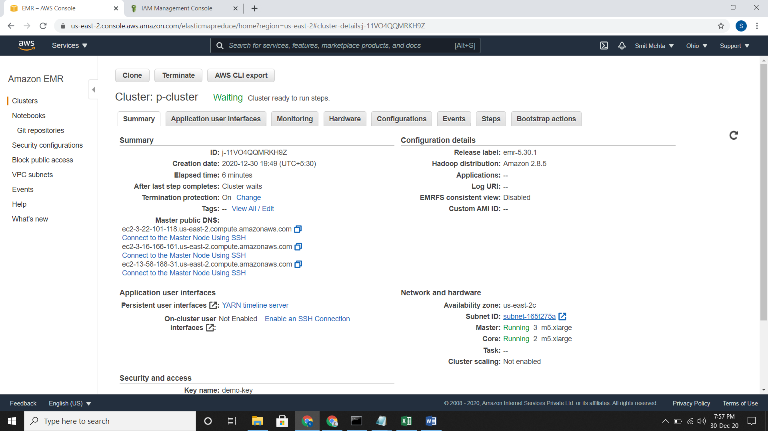

**For checking the cluster**

* Command aws emr describe-cluster –cluster-id

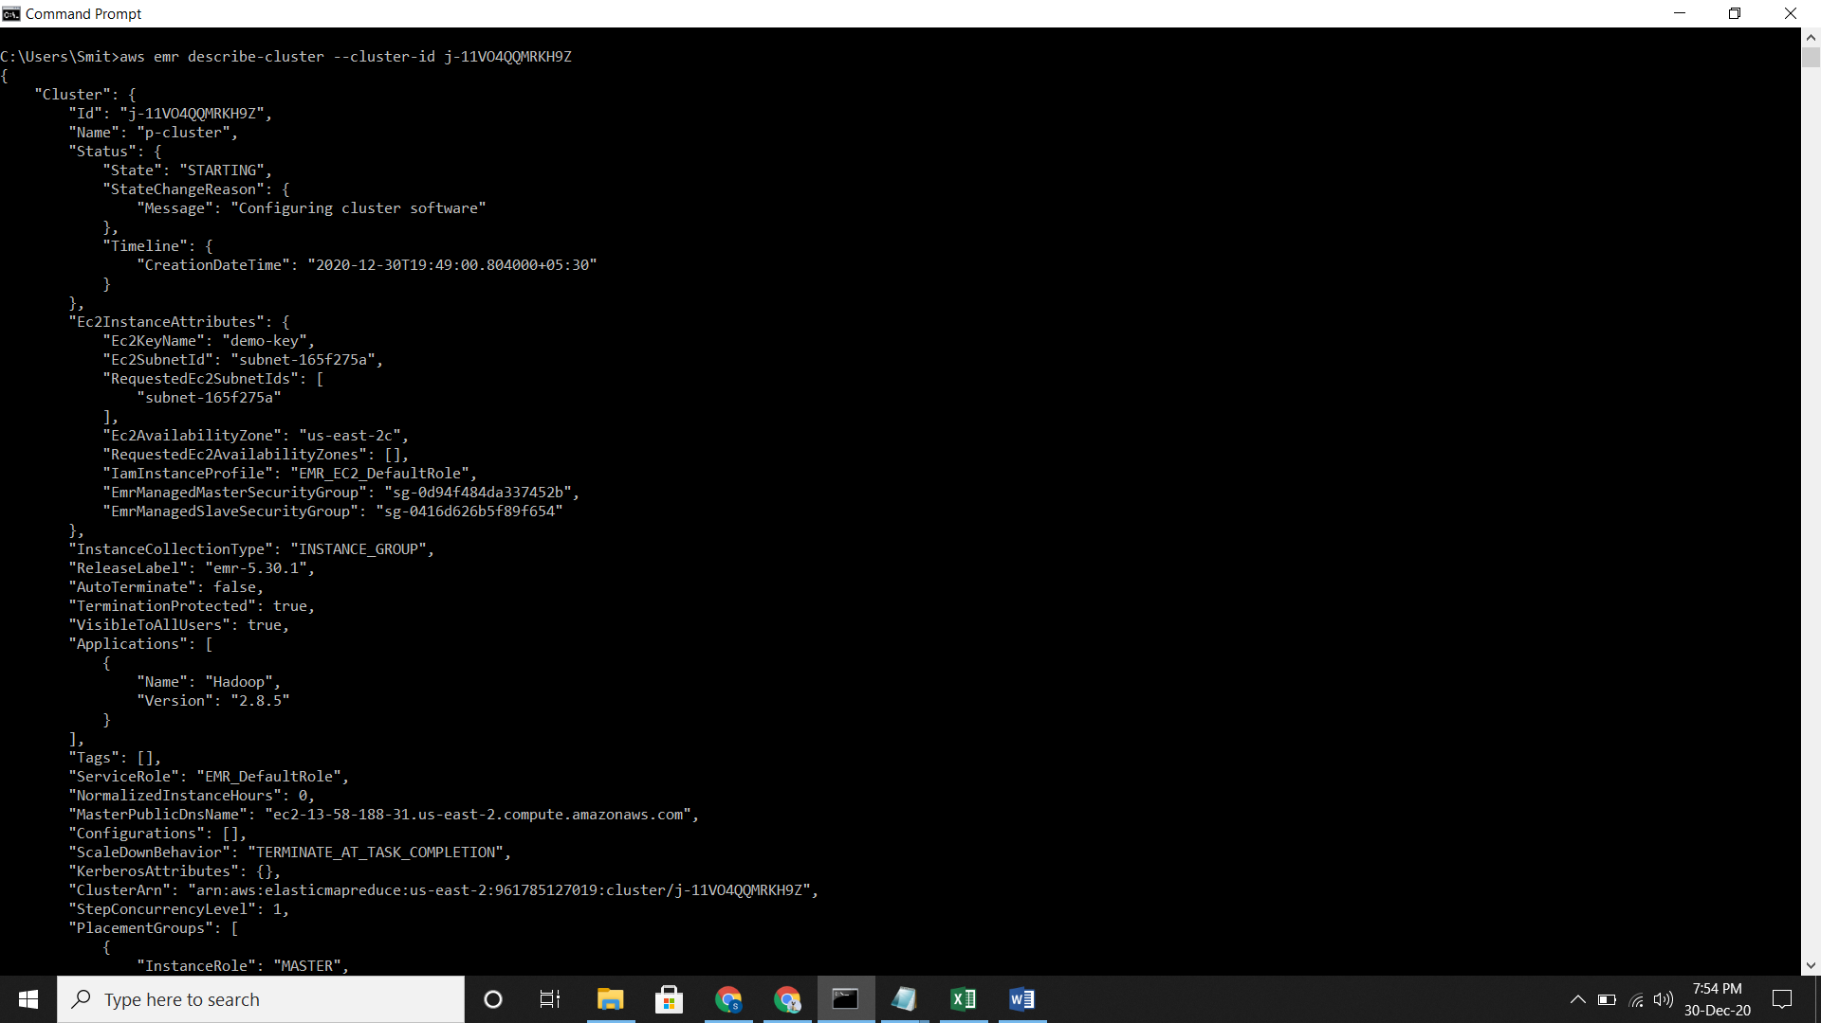 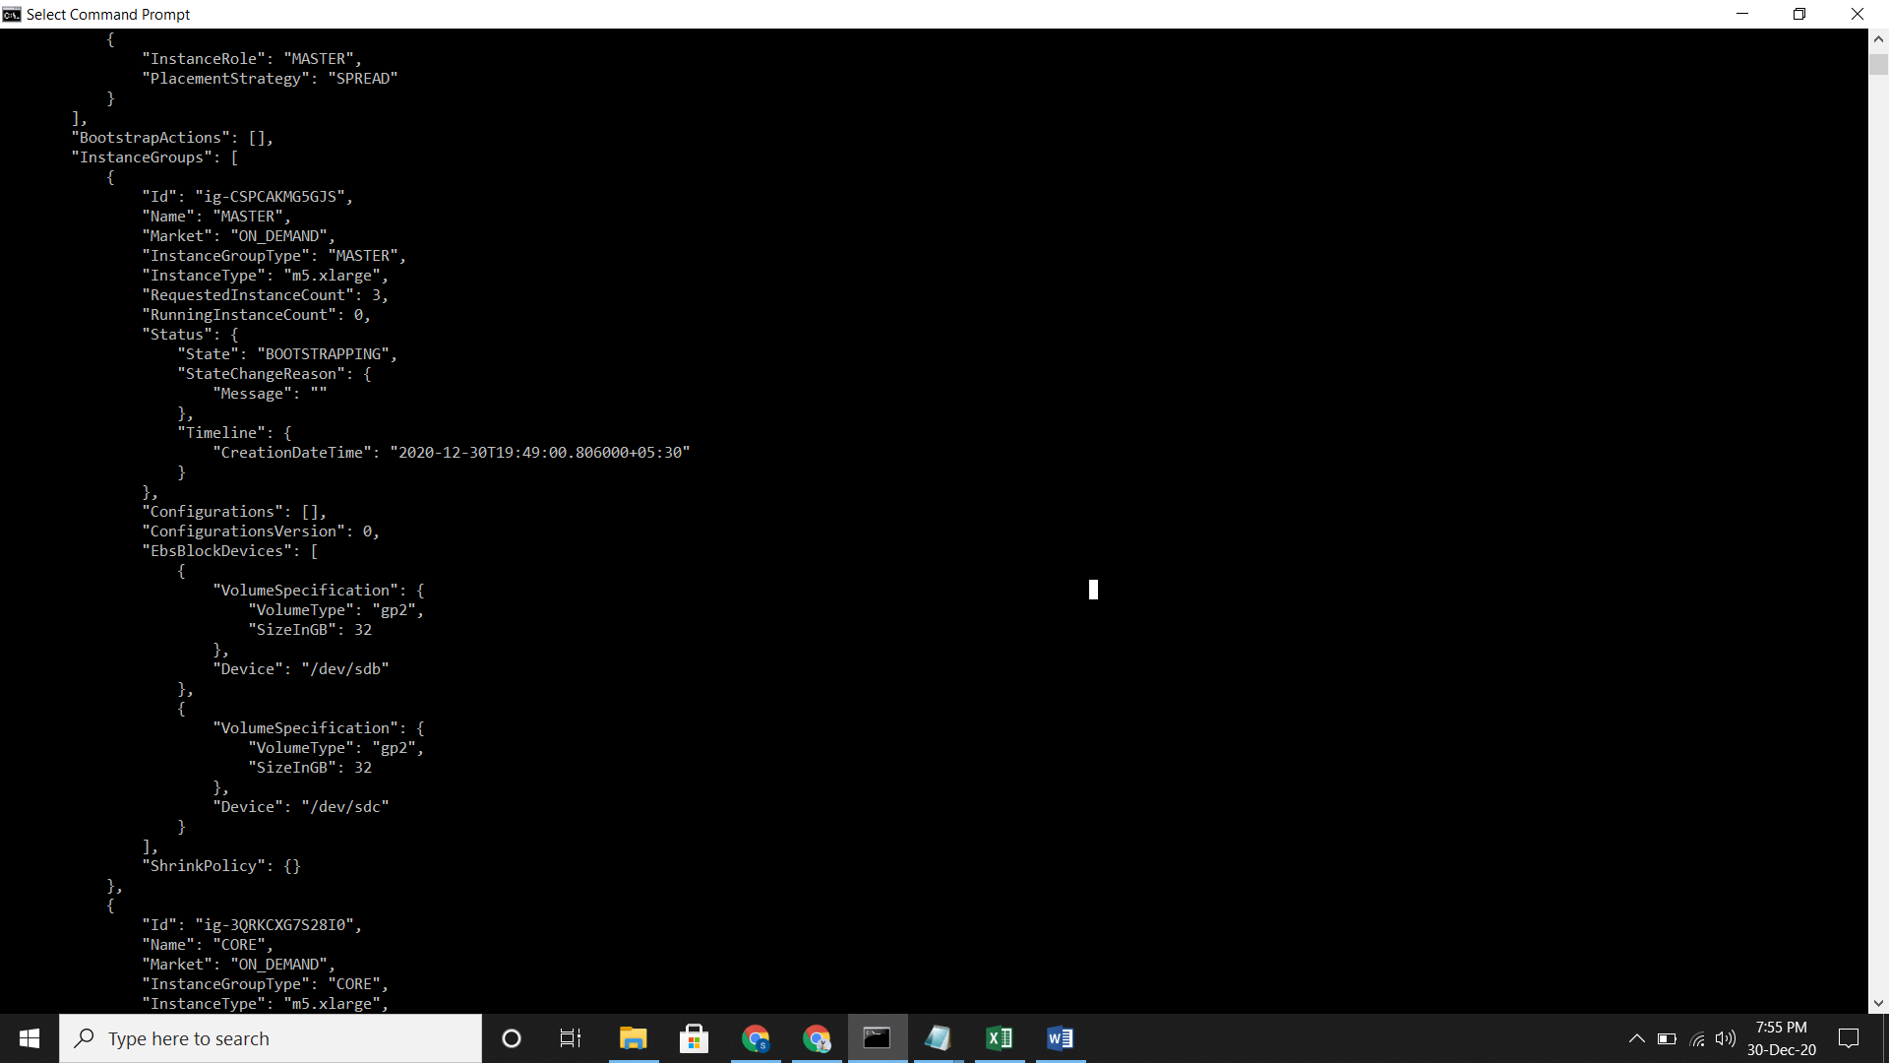

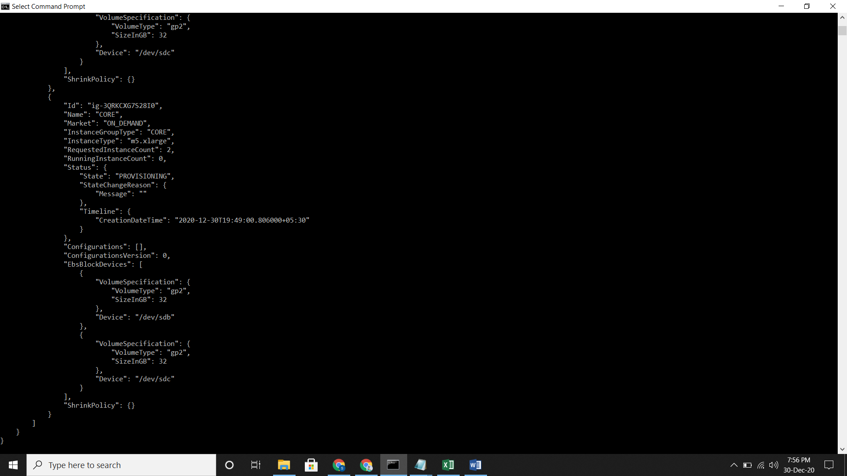

**EMR Clusters on AWS Outposts**

* On Console
* On AWS CLI
* Just type the command and cluster would be created in AWS Console.

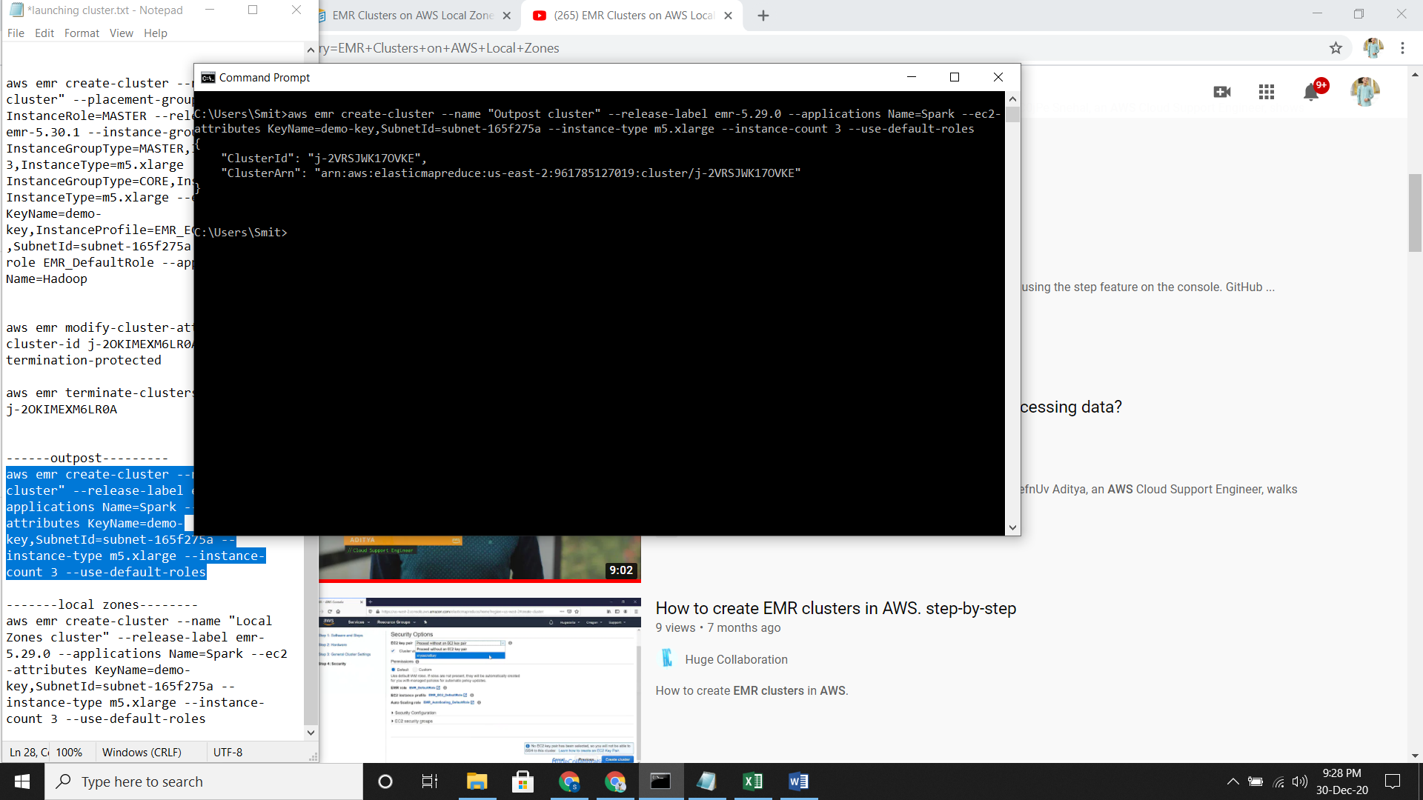

**EMR Clusters on AWS Local Zones**

* On Console
* On AWS CLI
* Just type the command and cluster would be created in AWS Console.

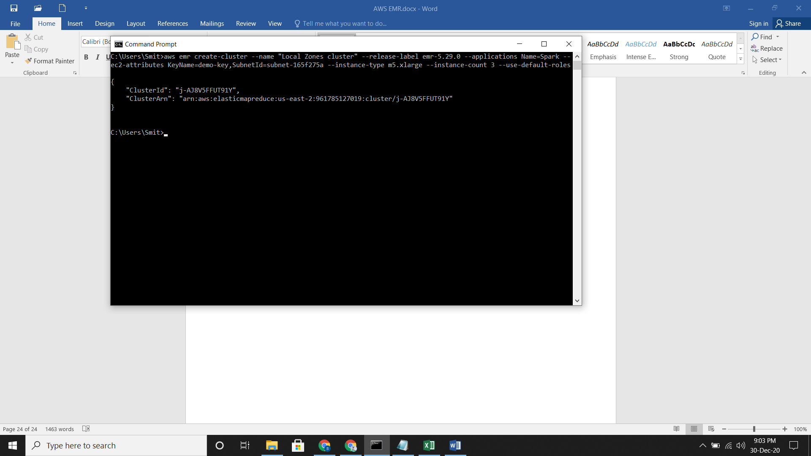

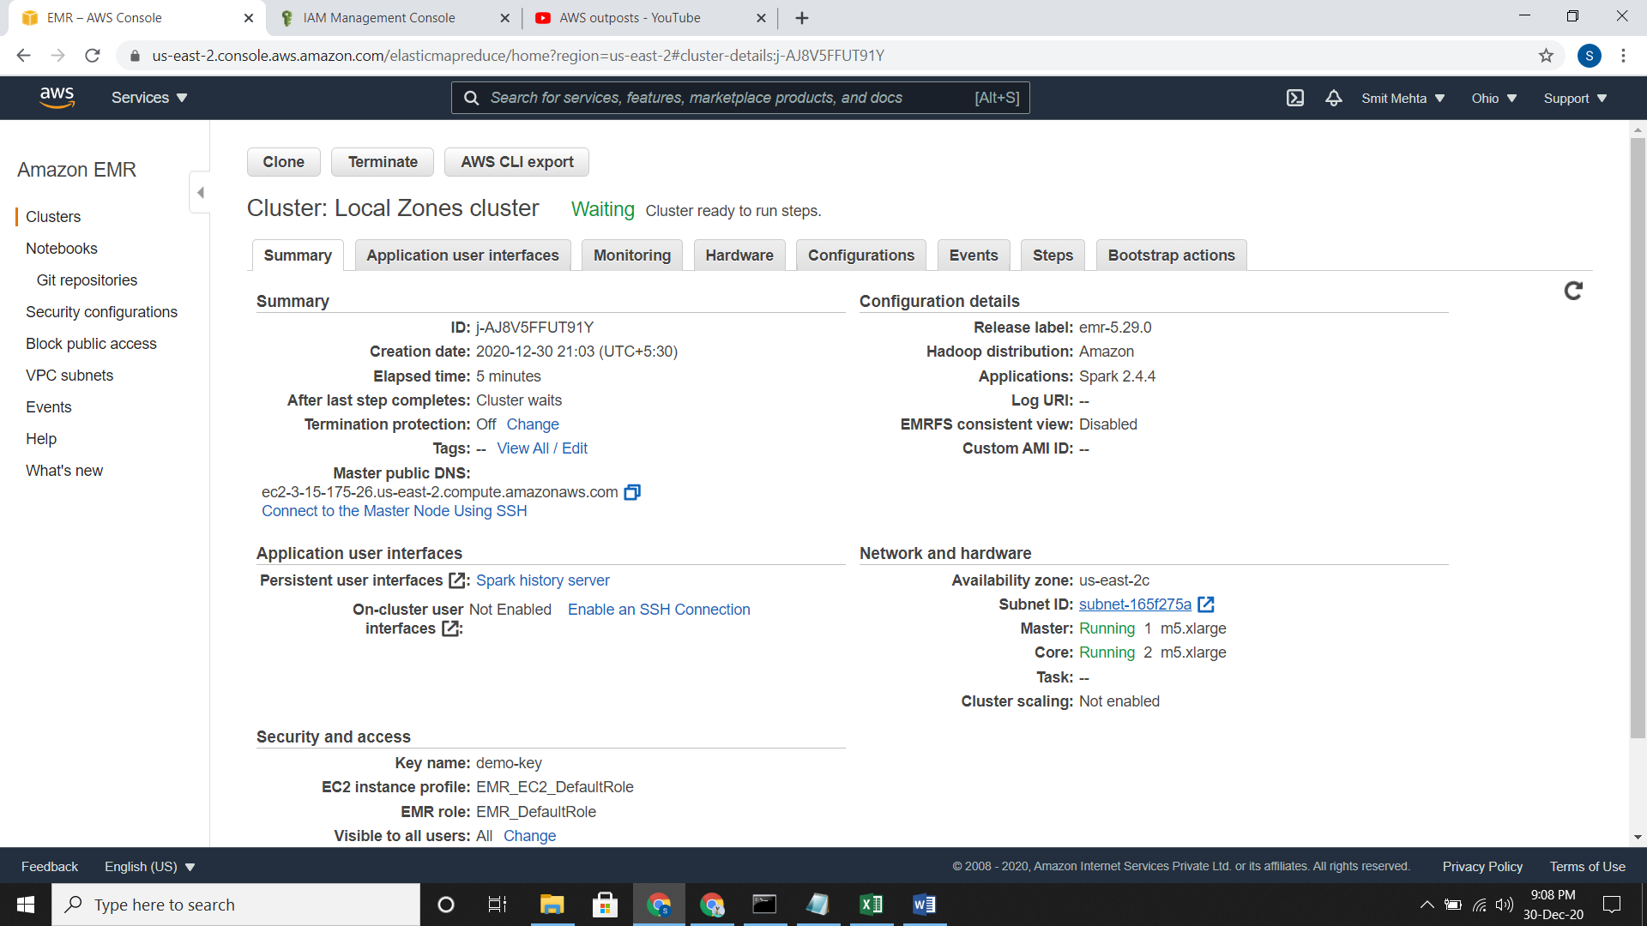

**Configure Docker**

**Enable Consistent View for EMRFS**

* On Console
* Go to clusters then advanced options and select Software & Hardware configurations.
* In general cluster setting under Additional Options, choose EMRFS consistent view.
* Choose Number of retries and retry period. AMI is optional.
* To check this, go to cluster details and see the EMRFS consistent view field has a value of Enabled or Disabled

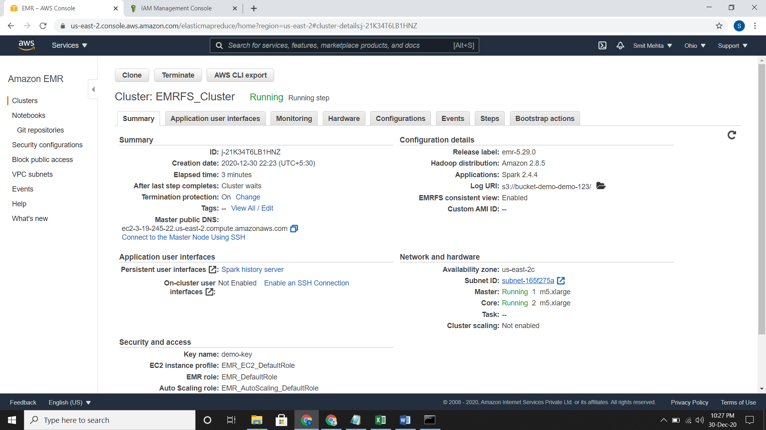

* On AWS CLI
* Just type the command and cluster would be created in AWS Console.
* aws emr create-cluster --instance-type m5.xlarge --instance-count 3 --emrfs Consistent=true --release-label emr-5.31.0 --ec2-attributes KeyName=demo-key